Course content

Contents

Simple but Powerful SQL Statements 1

3. What is PostgreSQL All About? 1

4. Database Design 1

5. Creating Tables 1

6. Analyzing CREATE TABLE 1

7. Inserting Data Into a Table 1

8. Retrieving Data with Select 1

9. Calculated Columns 1

10. Calculating Phone Revenue 1

Coding Exercise 2: Using Calculated Columns 1

11. Exercise Solution 1

12. String Operators and Functions 1

13. Filtering Rows with "Where" 1

14. More on the "Where" Keyword 2

15. Compound "Where" Clauses 2

16. A "Where" Exercise Overview 2

Coding Exercise 3: Practicing Where Statements 2

17. A "Where" Solution 2

18. "Where" With Lists 2

Coding Exercise 4: A More Challenging 'Where' 2

19. A "Where" With Lists Solution 2

20. Calculations in "Where" Clauses 2

Coding Exercise 5: Trying Calculations in Where Clauses 2

21. Solving Calculations 2

22. Updating Rows 2

23. Deleting Rows 3

Coding Exercise 6: Try Updating Records In a Table! 3

24. A Solution for Updating Rows 3

Coding Exercise 7: Practice Deleting Records 3

25. Solution for Deleting Rows 3

26. The Plan Moving Forward 3

27. Approaching Database Design 3

Quiz 2: Let's Design Some Schema 3

28. One-to-Many and Many-to-One Relationships 3

Quiz 3: A 'Has One' or 'Has Many'? 3

29. One-to-One and Many-to-Many Relationships 3

Quiz 4: Identifying One-to-One and Many-to-Many Relationships 3

30. Primary Keys and Foreign Keys 3

31. Understanding Foreign Keys 4

32. Auto-Generated ID's 4

33. Creating Foreign Key Columns 4

34. Running Queries on Associated Data 4

35. Exercise Overview 4

Coding Exercise 8: Creating and Using Foreign Keys 4

36. Foreign Key Creation Solution 4

37. Foreign Key Constraints Around Insertion 4

38. Constraints Around Deletion 5

39. Commands You’ll Need for the Next Video 5

40. Testing Deletion Constraints 5

41. Setting Foreign Keys to Null on Delete 5

Quiz 6: What Happens On Delete? 5

42. Adding Some Complexity 5

43. Adding Some Data 6

44. Queries with Joins and Aggregations 6

45. Joining Data from Different Tables 6

46. Another Quick Join 6

47. Exercise Overview 6

Coding Exercise 9: Practice Joining Data 6

48. A Joinful Solution 6

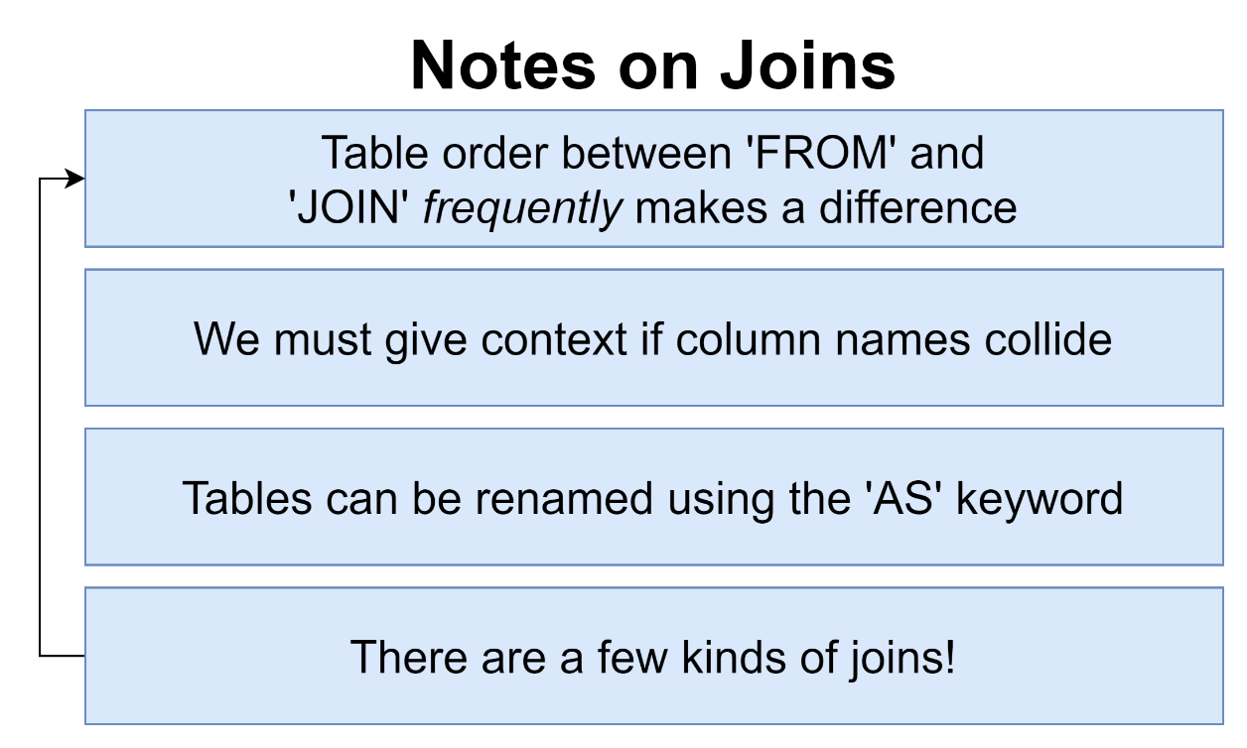 6

49. Alternate Forms of Syntax 6

50. Missing Data in Joins 7

51. Why Wasn't It Included 7

52. Four Kinds of Joins 7

53. Each Join in Practice 7

54. Does Order Matter? 7

Quiz 7: Test Your Joining Knowledge 7

55. Exercise Overview 7

Coding Exercise 10: Joins, Joins, Join! 7

56. Two Possible Solutions 7

57. Where with Join 7

58. Three Way Joins 7

59. A Bit of Practice 7

Coding Exercise 11: Three Way Exercise 8

60. Exercise Solution 8

76. A New Dataset 8

77. Investigating This Dataset 8

78. Some Group By Practice 8

Coding Exercise 15: Group By Review 9

79. Group By Review Solution 9

80. Remember Joins? 9

Coding Exercise 16: Inner Join Review 10

81. Of Course You Remember! 10

82. The Basics of Sorting 10

83. Two Variations on Sorting 10

84. Offset and Limit 10

85. Exercise Overview 10

Coding Exercise 17: Sorting, Offsetting, and Limiting 10

86. Exercise Solution 10

87. Handling Sets with Union 10

88. A Few Notes on Union 10

89. Commonalities with Intersect 11

90. Removing Commonalities with Except 11

91. Union Exercise Overview 11

Coding Exercise 18: Merging Results with Union 11

92. Exercise Solution 11

93. What's a Subquery? 12

94. Thinking About the Structure of Data 12

Quiz 9: What's the Data Look Like? 12

95. Subqueries in a Select 12

96. Exercise Overview 12

Coding Exercise 19: Embedding in Select 12

97. Select Solution 12

98. Subqueries in a From 13

99. From Subqueries that Return a Value 13

100. Example of a Subquery in a From 13

101. Exercise Overview 13

Coding Exercise 20: Subquery From's 13

102. Exercise Solution 13

103. Subqueries in a Join Clause 14

104. More Useful - Subqueries with Where 14

105. Data Structure with Where Subqueries 15

106. Exercise Overview 15

Coding Exercise 21: Subquery Where's 15

107. Exercise Solution 15

108. The Not In Operator with a List 15

109. A New Where Operator 15

110. Finally Some! 16

Quiz 10: Is It A Valid Subquery? 17

111. Exercise Overview 17

Coding Exercise 22: Practice Your Subqueries! 17

112. A Quick Solution 17

113. Probably Too Much About Correlated Subqueries 17

114. More on Correlated Subqueries 18

115. A Select Without a From? 19

116. Exercise Overview 19

Coding Exercise 23: From-less Selects 19

117. Exercise Solution 19

118. Selecting Distinct Values 19

119. Exercise Overview 19

Coding Exercise 24: Some Practice with Distinct 19

120. A Distinct Solution 19

121. The Greatest Value in a List 19

122. And the Least Value in a List! 20

123. The Case Keyword 20

124. PostgreSQL Installation on macOS 20

125. pgAdmin Setup on macOS 20

126. Postgres installation on Windows 20

127. What'd We Just Do? 20

128. Data Types 20

129. Fast Rules on Numeric Data Types 21

130. More on Number Data Types 21

131. Reminder on Character Types 22

132. Boolean Data Types 22

133. Times, Dates, and Timestamps 22

134. Really Awesome Intervals 24

135. Thinking About Validation 25

136. Creating and Viewing Tables in PGAdmin 25

137. Applying a Null Constraint 25

138. Solving a Gotcha with Null Constraints 25

Quiz 11: Creating NULL Constraints 25

139. Default Column Values 25

140. Applying a Unique Constraint to One column 25

141. Multi-Column Uniqueness 26

Quiz 12: Is It Unique? 26

142. Adding a Validation Check 26

143. Checks Over Multiple Columns 26

Quiz 13: Does It Pass a Check? 27

144. So Where Are We Applying Validation? 27

145. Approaching More Complicated Designs 27

146. Using a SQL Design Tool 27

147. A Config-based Schema Designer 28

148. Here's the Plan 28

149. Rebuilding Some Schema 28

150. Requirements of a Like System 28

151. How Not to Design a Like System 28

152. Designing a Like System 29

Quiz 14: Building a Similar System 29

153. Making a Reaction System Instead 29

154. Polymorphic Associations 30

155. Polymorphic Association Alternative Implementation 30

156. The Simplest Alternative 30

Quiz 15: Polymorphic Associations 30

157. So Which Approach? 30

158. Additional Features Around Posts 30

159. Adding Captions and Locations 30

160. Photo Mentions vs Caption Mentions 30

161. Considerations on Photo Tags vs Caption Tags 30

162. Update For Tags 30

163. Designing a Hashtag System 30

164. Tables for Hashtags 30

165. Including the Hashtag Table 31

166. A Few More User Columns 31

167. Why No Number of Followers or Posts? 31

168. Designing a Follower System 31

169. Back to Postgres 31

170. Creating Tables with Checks 31

171. Posts Creation 31

172. Comments Creation 31

173. Likes Creation 31

174. Photo Tags and Caption Tags 31

175. Creating Hashtags, Hashtag Posts, and Followers 31

176. Quick Note About Adding Some Data 32

177. Adding Some Data 32

178. Restoring from Scratch 32

179. Highest User ID's Exercise 32

180. Solution for User ID's 32

181. Posts by a Particular User 32

182. Solving for Posts by User 32

183. Likes Per User 32

184. Solution for Likes Per User 32

185. Thinking About Performance 32

186. Where Does Postgres Store Data? 32

187. Heaps, Blocks, and Tuples 33

Quiz 16: Terminology Check 33

188. Block Data Layout 33

189. Heap File Layout 33

190. Full Table Scans 33

191. What's an Index 33

192. How an Index Works 33

193. Creating an Index 33

194. Benchmarking Queries 33

195. Downsides of Indexes 33

196. Index Types 33

197. Automatically Generated Indexes 33

Quiz 17: Using Automatically Created Indexes 34

198. Behind the Scenes of Indexes 34

199. The Query Processing Pipeline 34

200. Explain and Explain Analyze 34

Quiz 18: Explain Vs Explain Analyze 34

201. Solving an Explain Mystery 34

202. Developing an Intuitive Understanding of Cost 34

203. Calculating Cost by Hand 34

204. A Touch More on Costs 34

Quiz 19: Calculating Costs 34

205. up vs Total Costs 34

206. Costs Flow Up 34

207. Use My Index! 35

208. Common Table Expressions 35

209. A Quick Solution 35

210. So What's a CTE? 35

211. Recursive CTE's 35

212. Recursive CTE's Step by Step 35

213. Why Use Recursive CTE's? 35

214. Writing the Query 35

215. Walking Through Recursion 35

216. Most Popular Users 35

217. A Possible Solution for Merging Tables 35

218. Creating a View 36

219. When to Use a View? 36

220. Deleting and Changing Views 36

221. Materialized Views 36

222. Grouping by Week 36

223. Reminder on Left Joins 36

224. Writing a Slow Query 36

225. Creating and Refreshing Materialized Views 36

Quiz 20: Views vs Materialized Views 36

226. What are Transactions Used For? 36

227. Some Sample Data 36

228. Opening and Closing Transactions 36

229. Transaction Cleanup on Crash 37

230. Closing Aborted Transactions 37

231. A Story on Migrations 37

232. Migration Files 37

233. Issues Solved by Migrations 37

234. A Few Notes on Migrations Libraries 37

235. A Note About Node Installation 37

236. Project Creation 37

237. Generating and Writing Migrations 37

238. Applying and Reverting Migrations 37

239. Generating and Applying a Second Migration 37

240. Schema vs Data Migrations 38

241. Dangers Around Data Migrations 38

242. Properly Running Data and Schema Migrations 38

243. Creating a Posts Table 38

244. A Small Web Server 38

245. Web Server Setup Instructions 38

246. Adding the Loc Column 38

247. Writing Values to Both Columns 38

248. Transaction Locks 38

249. Updating Values 38

250. Migrations Setup Instructions 38

251. Updating the App Server 39

252. Dropping the Last Columns 39

253. Section Goal 39

254. Initial Setup 39

255. One Fast Migration 39

256. Building the Users Router 39

257. Understanding Connection Pools 39

258. Validating Connection Credentials 39

259. Query and Close 39

260. The Repository Pattern 39

261. Creating a Repository 39

262. Accessing the API 40

263. Casing Issues 40

264. Fixing Casing 40

265. Finding Particular Users 40

266. SQL Injection Exploits 40

267. Handling SQL Injection with Prepared Statements 40

268. Preventing SQL Injection 40

269. Reminder on Post Requests 40

270. Inserting Users 40

271. Handling Updates 40

272. And, Finally, Delete 40

273. A Note on Testing 41

274. Assertions Around User Count 41

275. Connecting to a DB For Tests 41

276. Disconnecting After Tests 41

277. Multi-DB Setup 41

278. Assumptions Around Content 41

279. Issues with Parallel Tests 41

280. Isolation with Schemas 41

281. Creating and Accessing Schemas 41

282. Controlling Schema Access with Search Paths 41

283. Routing Schema Access 41

284. Strategy for Isolation 42

285. Programmatic Schema Creation 42

286. Escaping Identifiers 42

287. Test Helpers 42

288. Cleaning up Schemas and Roles 42

289. Finally... Parallel Tests! (Final Lecture) 42

290. Bonus! 42

# Simple but Powerful SQL Statements

## 3. What is PostgreSQL All About?

## 4. Database Design

Quiz 1: Database Terminology

## 5. Creating Tables

## 6. Analyzing CREATE TABLE

## 7. Inserting Data Into a Table

## 8. Retrieving Data with Select

Coding Exercise 1: Create, Insert, and Select!

## 9. Calculated Columns

## 10. Calculating Phone Revenue

## Coding Exercise 2: Using Calculated Columns

## 11. Exercise Solution

## 12. String Operators and Functions

## 13. Filtering Rows with "Where"

## 14. More on the "Where" Keyword

## 15. Compound "Where" Clauses

## 16. A "Where" Exercise Overview

## Coding Exercise 3: Practicing Where Statements

## 17. A "Where" Solution

## 18. "Where" With Lists

## Coding Exercise 4: A More Challenging 'Where'

## 19. A "Where" With Lists Solution

## 20. Calculations in "Where" Clauses

## Coding Exercise 5: Trying Calculations in Where Clauses

## 21. Solving Calculations

## 22. Updating Rows

## 23. Deleting Rows

## Coding Exercise 6: Try Updating Records In a Table!

## 24. A Solution for Updating Rows

## Coding Exercise 7: Practice Deleting Records

## 25. Solution for Deleting Rows

## 26. The Plan Moving Forward

## 27. Approaching Database Design

## Quiz 2: Let's Design Some Schema

## 28. One-to-Many and Many-to-One Relationships

## Quiz 3: A 'Has One' or 'Has Many'?

## 29. One-to-One and Many-to-Many Relationships

## Quiz 4: Identifying One-to-One and Many-to-Many Relationships

## 30. Primary Keys and Foreign Keys

## 31. Understanding Foreign Keys

Quiz 5: Foreign Keys; How Do They Work?

## 32. Auto-Generated ID's

## 33. Creating Foreign Key Columns

## 34. Running Queries on Associated Data

## 35. Exercise Overview

## Coding Exercise 8: Creating and Using Foreign Keys

## 36. Foreign Key Creation Solution

## 37. Foreign Key Constraints Around Insertion

## 38. Constraints Around Deletion

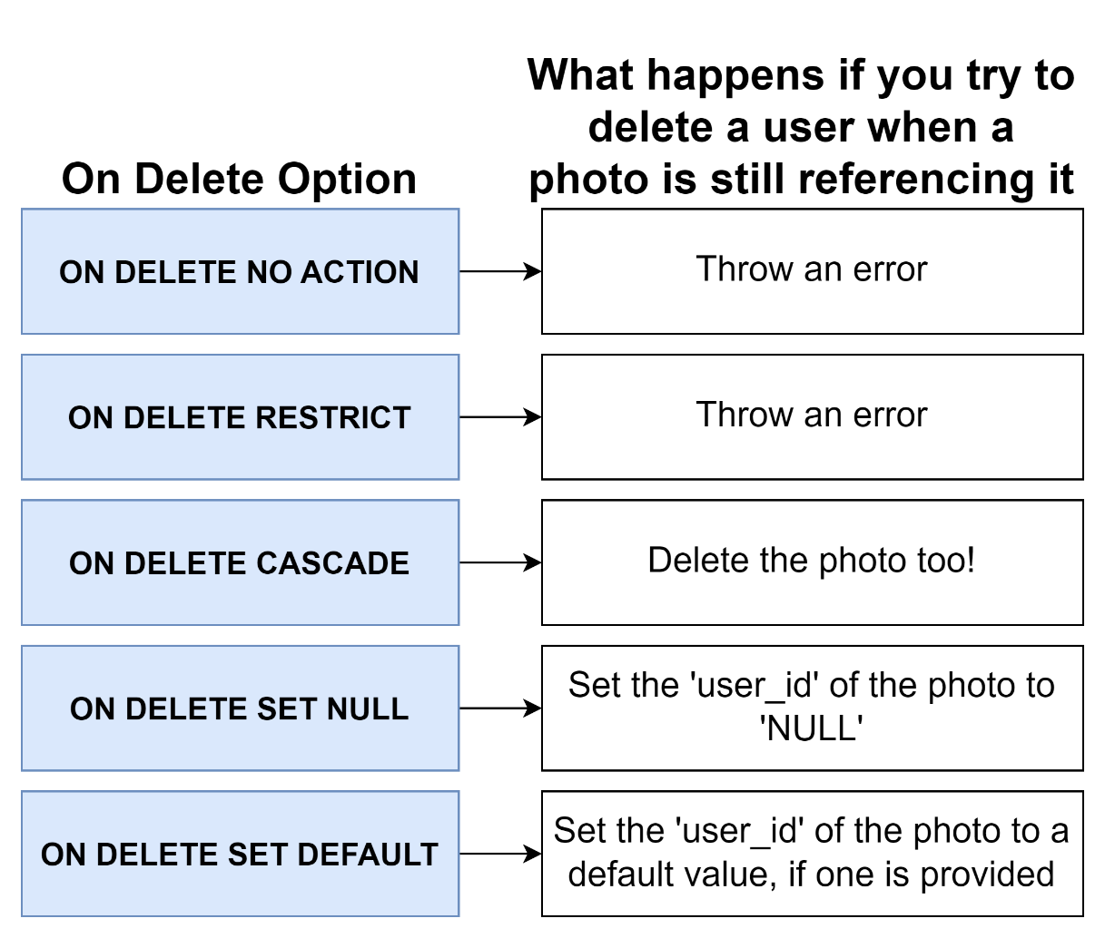

## 39. Commands You’ll Need for the Next Video

## 40. Testing Deletion Constraints

## 41. Setting Foreign Keys to Null on Delete

## Quiz 6: What Happens On Delete?

## 42. Adding Some Complexity

## 43. Adding Some Data

## 44. Queries with Joins and Aggregations

## 45. Joining Data from Different Tables

## 46. Another Quick Join

## 47. Exercise Overview

## Coding Exercise 9: Practice Joining Data

## 48. A Joinful Solution

## 

## 49. Alternate Forms of Syntax

## 50. Missing Data in Joins

## 51. Why Wasn't It Included

## 52. Four Kinds of Joins

## 53. Each Join in Practice

## 54. Does Order Matter?

## Quiz 7: Test Your Joining Knowledge

## 55. Exercise Overview

## Coding Exercise 10: Joins, Joins, Join!

## 56. Two Possible Solutions

## 57. Where with Join

## 58. Three Way Joins

## 59. A Bit of Practice

## Coding Exercise 11: Three Way Exercise

## 60. Exercise Solution

## 76. A New Dataset

## 77. Investigating This Dataset

## 78. Some Group By Practice

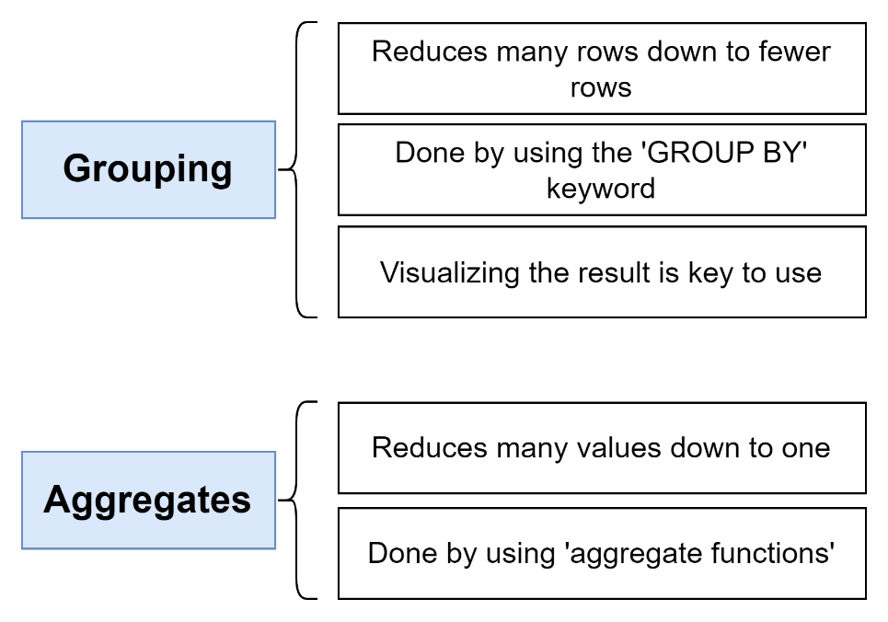

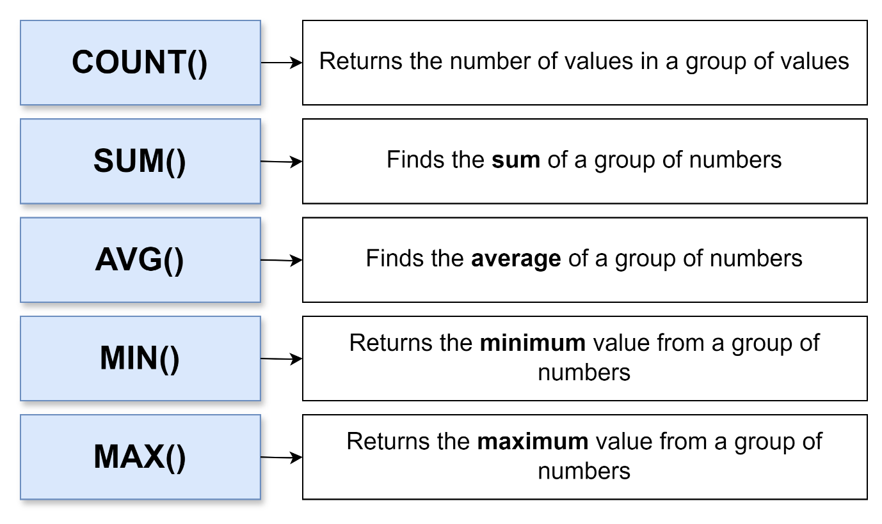

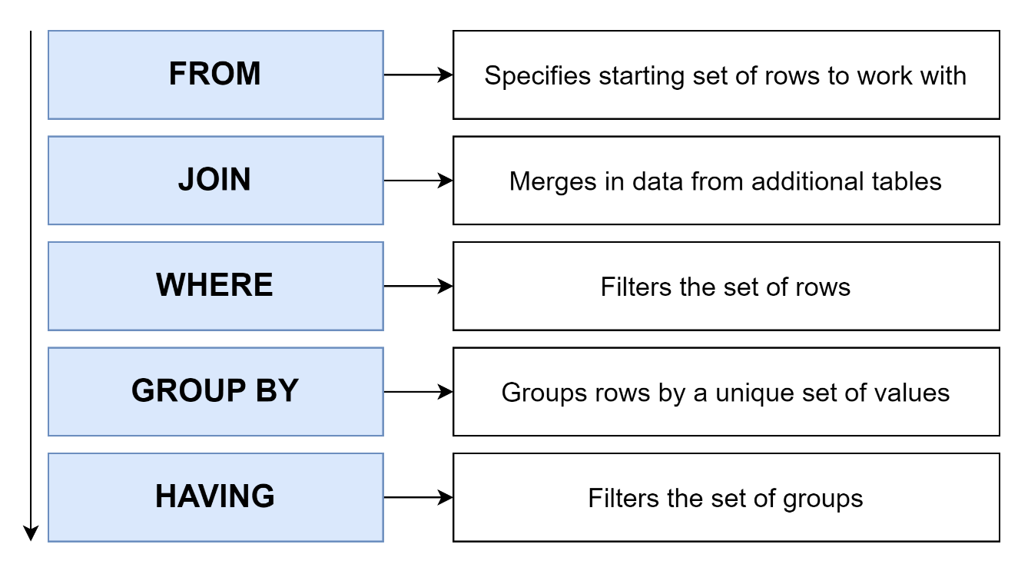

## Coding Exercise 15: Group By Review

## 79. Group By Review Solution

## 80. Remember Joins?

## Coding Exercise 16: Inner Join Review

## 81. Of Course You Remember!

## 82. The Basics of Sorting

## 83. Two Variations on Sorting

## 84. Offset and Limit

## 85. Exercise Overview

## Coding Exercise 17: Sorting, Offsetting, and Limiting

## 86. Exercise Solution

## 87. Handling Sets with Union

## 88. A Few Notes on Union

UNION 🡪 Join together results of 2 queries and remove duplicate rows

UNION ALL 🡪

INTERSECT 🡪 Find rows in common in the results of 2 queries and remove duplicate rows

INTERSECT ALL 🡪

EXCEPT 🡪 Find rows that are present in first query but not second query and remove duplicate rows

EXCEPT ALL 🡪

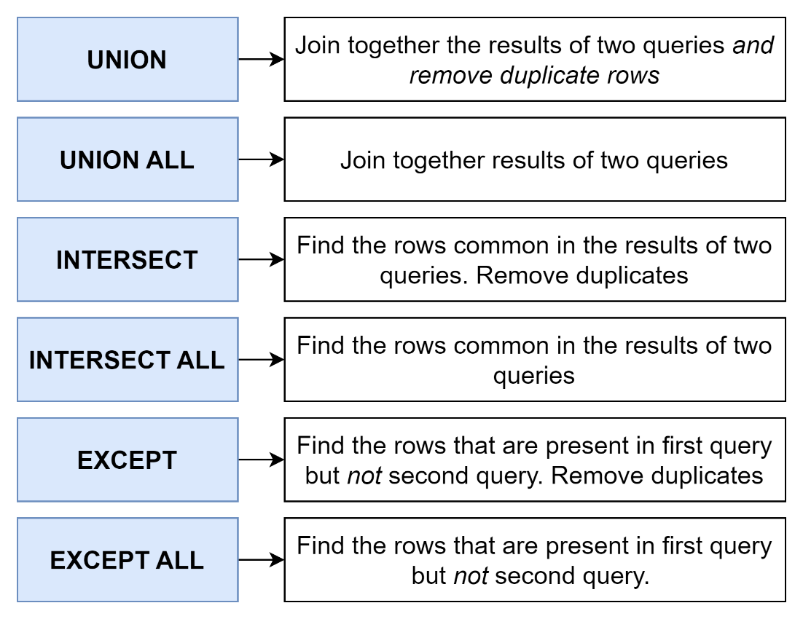

## 89. Commonalities with Intersect

## 90. Removing Commonalities with Except

## 91. Union Exercise Overview

## Coding Exercise 18: Merging Results with Union

## 92. Exercise Solution

## 93. What's a Subquery?

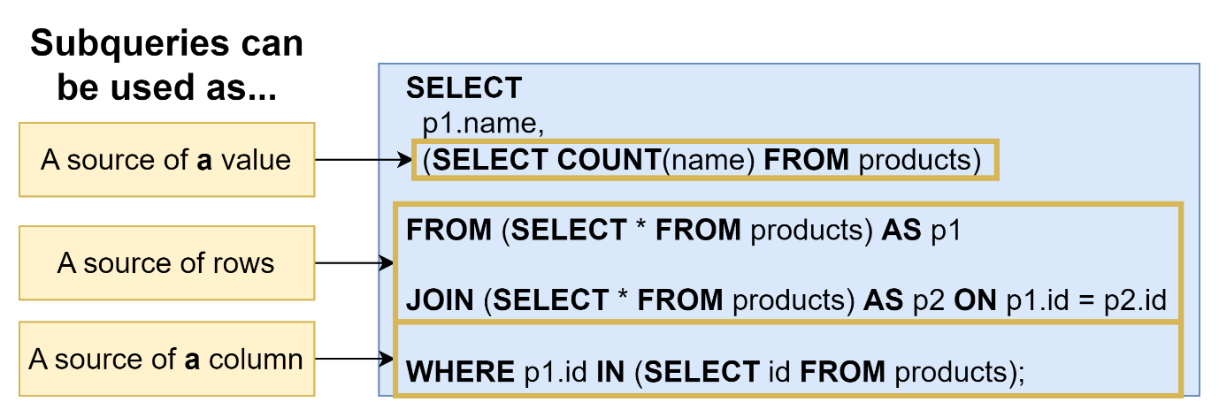

## 94. Thinking About the Structure of Data

## Quiz 9: What's the Data Look Like?

## 95. Subqueries in a Select

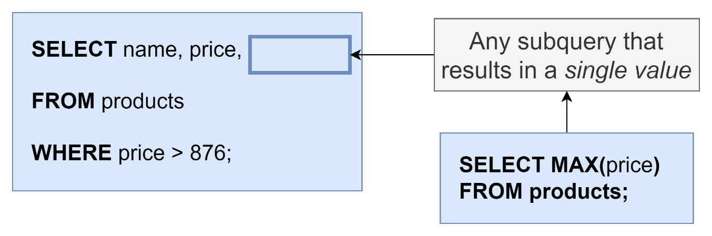

## 96. Exercise Overview

## Coding Exercise 19: Embedding in Select

## 97. Select Solution

## 98. Subqueries in a From

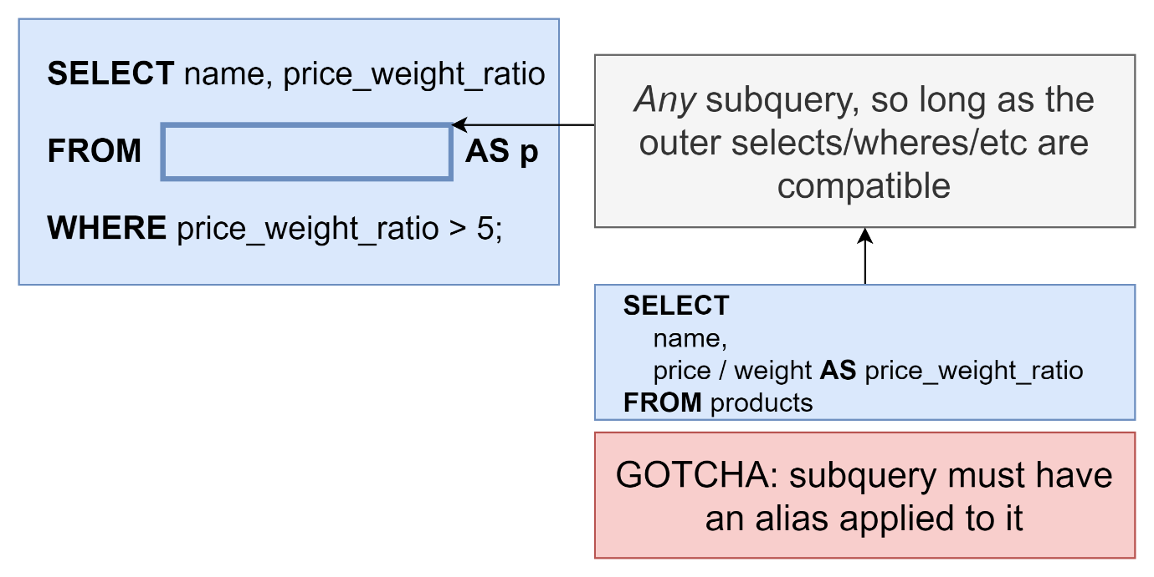

## 99. From Subqueries that Return a Value

## 100. Example of a Subquery in a From

## 101. Exercise Overview

## Coding Exercise 20: Subquery From's

## 102. Exercise Solution

## 103. Subqueries in a Join Clause

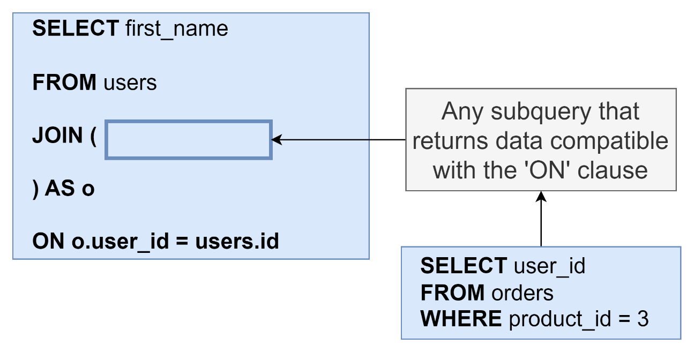

## 104. More Useful - Subqueries with Where

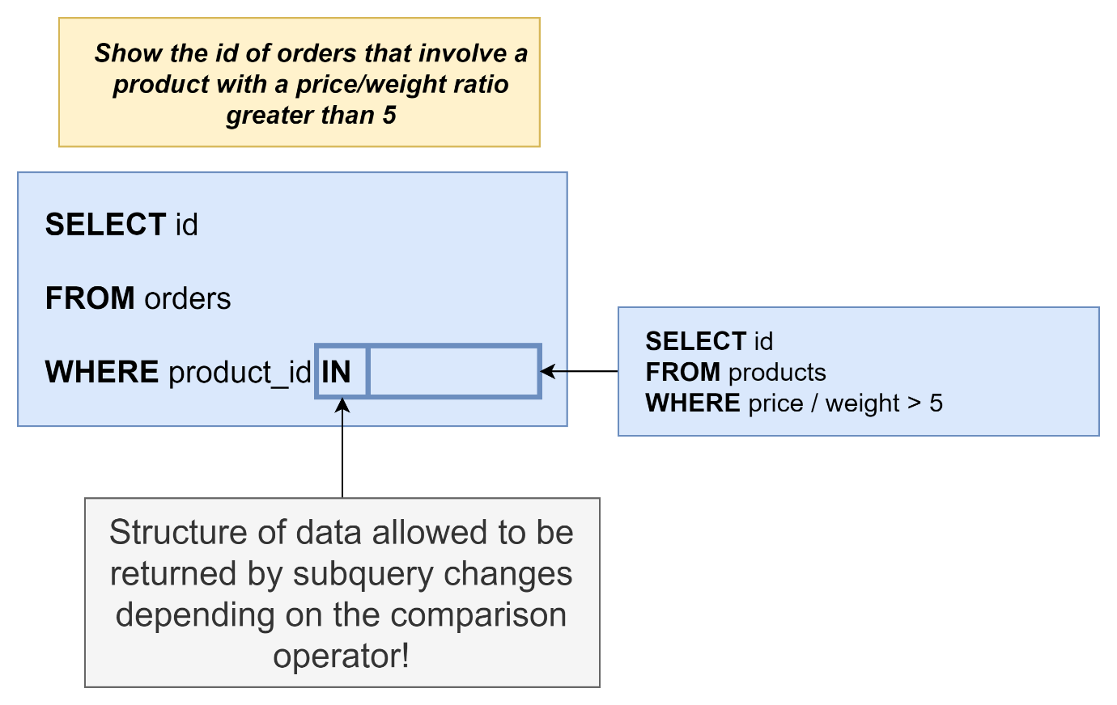

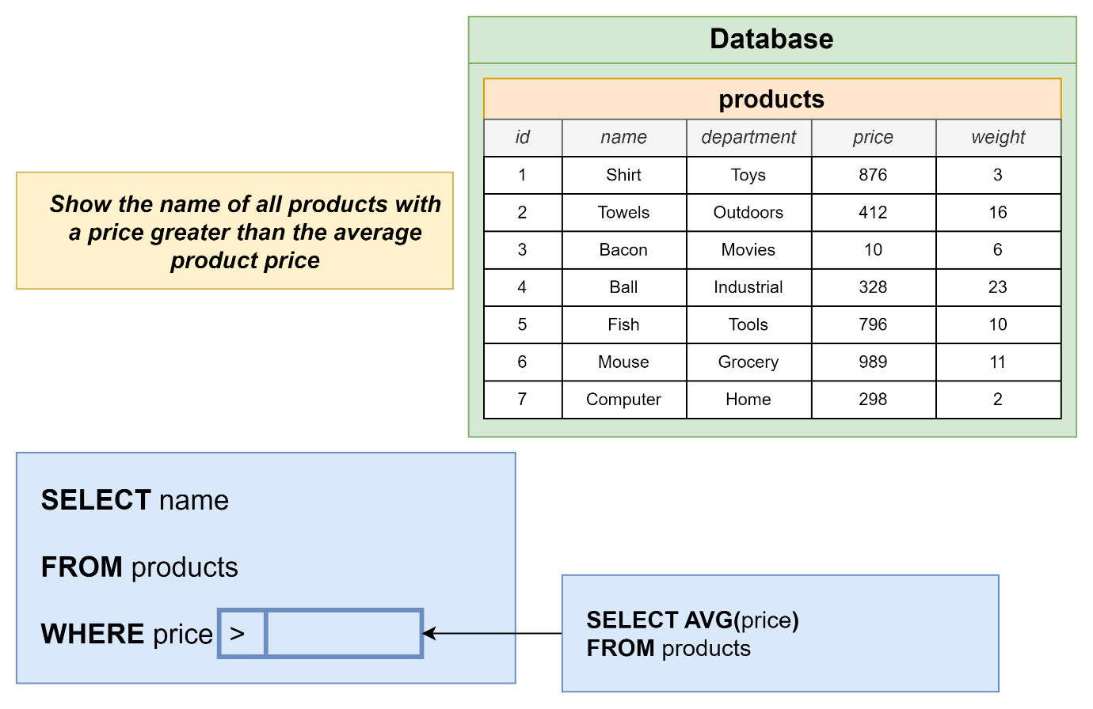

## 105. Data Structure with Where Subqueries

## 106. Exercise Overview

## Coding Exercise 21: Subquery Where's

## 107. Exercise Solution

## 108. The Not In Operator with a List

## 109. A New Where Operator

## 110. Finally Some!

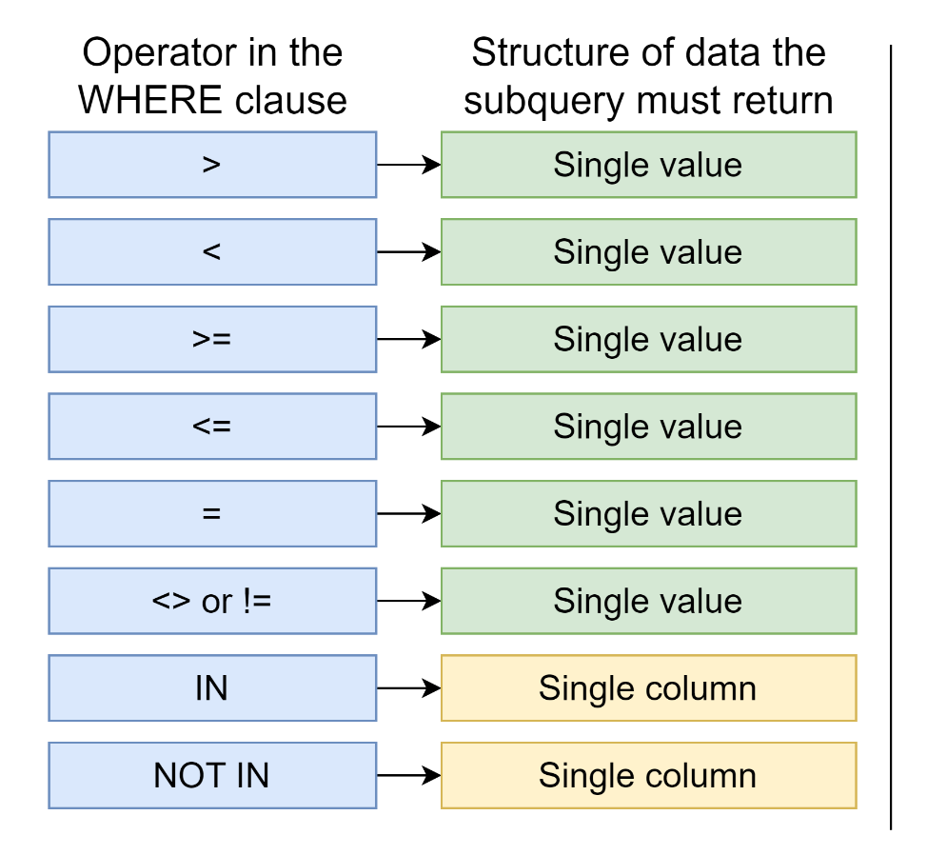

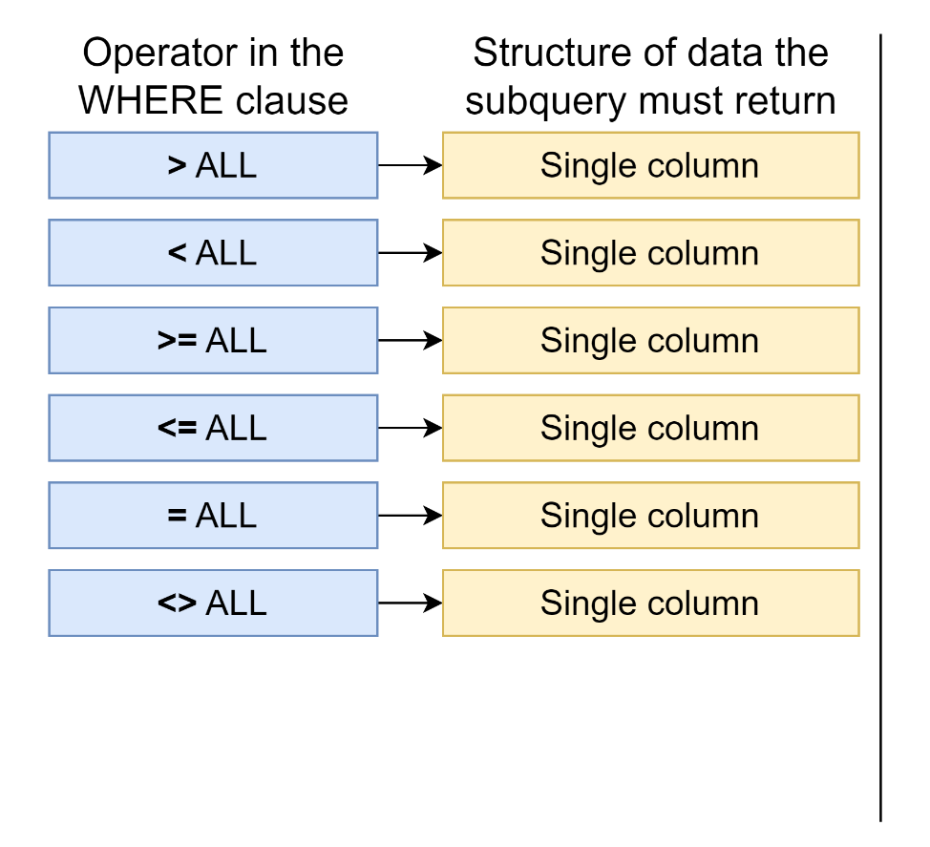

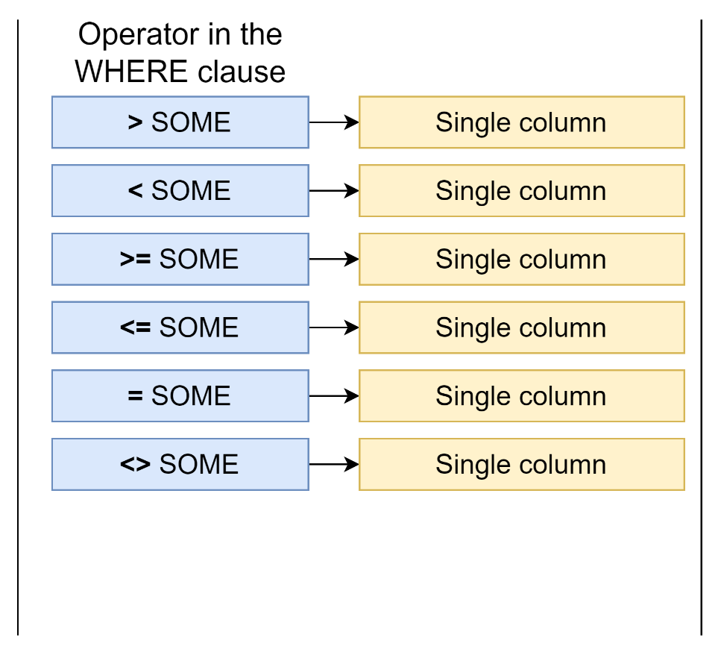

## Quiz 10: Is It A Valid Subquery?

## 111. Exercise Overview

## Coding Exercise 22: Practice Your Subqueries!

## 112. A Quick Solution

## 113. Probably Too Much About Correlated Subqueries

## 114. More on Correlated Subqueries

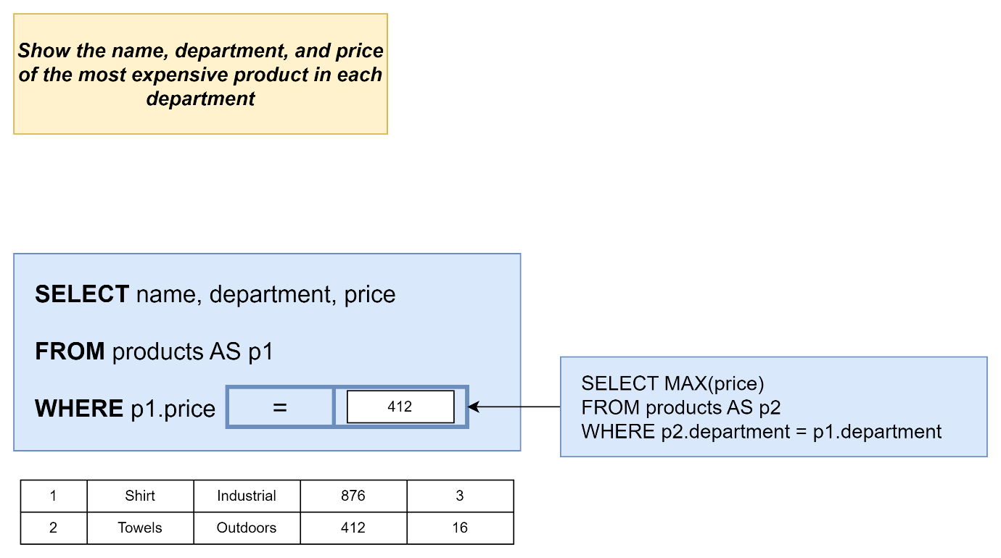

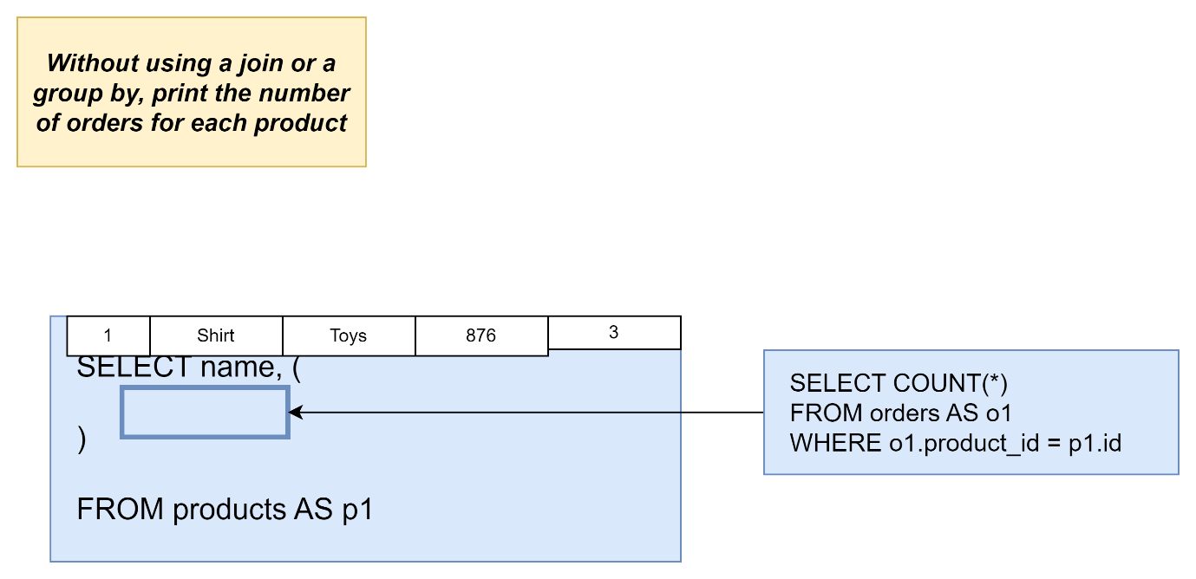

## 115. A Select Without a From?

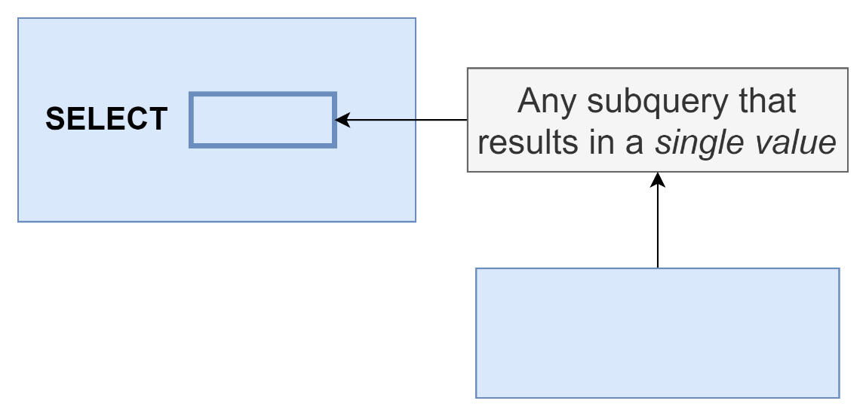

## 116. Exercise Overview

## Coding Exercise 23: From-less Selects

## 117. Exercise Solution

## 118. Selecting Distinct Values

## 119. Exercise Overview

## Coding Exercise 24: Some Practice with Distinct

## 120. A Distinct Solution

## 121. The Greatest Value in a List

Select name,weight , greatest(30,2*weight)

From products;

## 122. And the Least Value in a List!

## 123. The Case Keyword

Select name,price

CASE

When price > 500 then ‘high’

When price < 300 then ‘medium’

Else ‘cheap’

END

From products;

## 124. PostgreSQL Installation on macOS

## 125. pgAdmin Setup on macOS

## 126. Postgres installation on Windows

## 127. What'd We Just Do?

## 128. Data Types

## 129. Fast Rules on Numeric Data Types

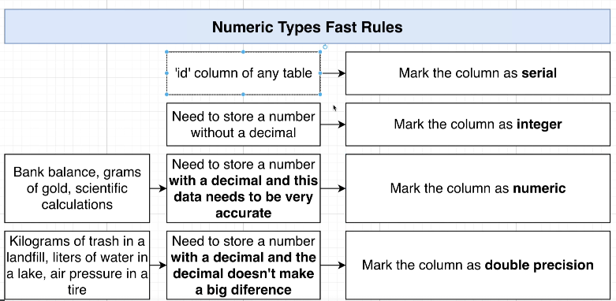

## 130. More on Number Data Types

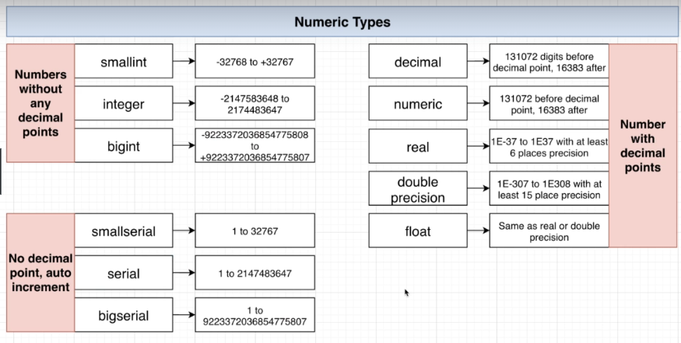

## 131. Reminder on Character Types

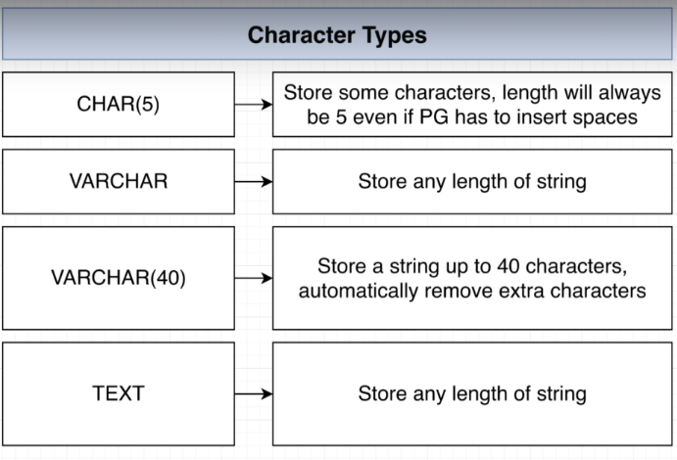

No performance difference

## 132. Boolean Data Types

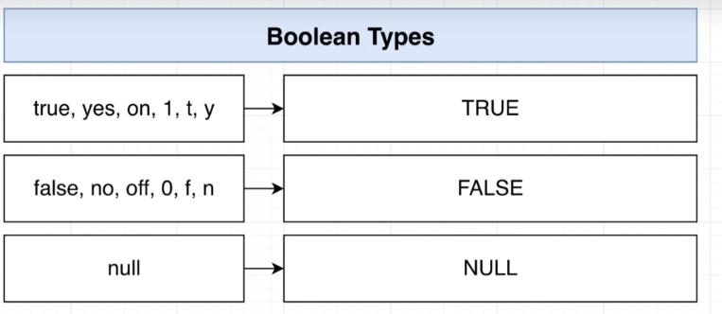

Null isnot true nor false

## 133. Times, Dates, and Timestamps

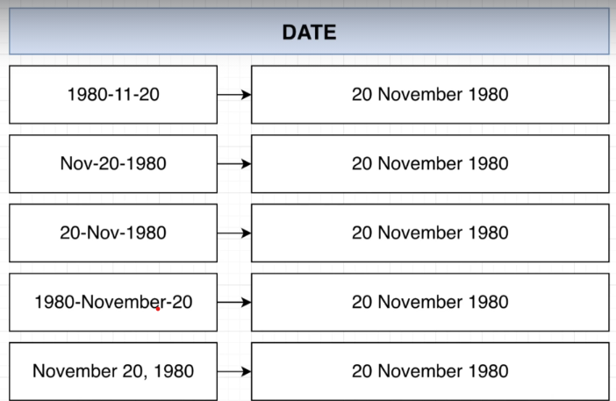

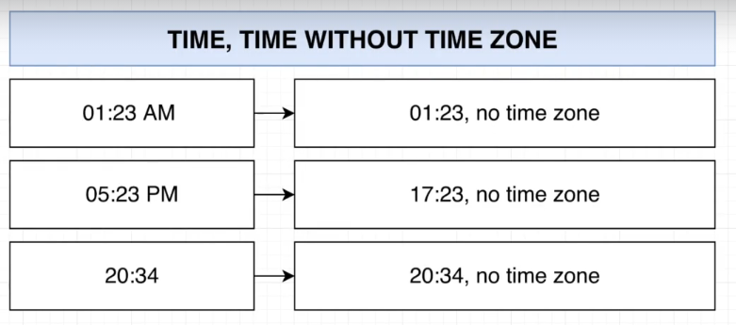

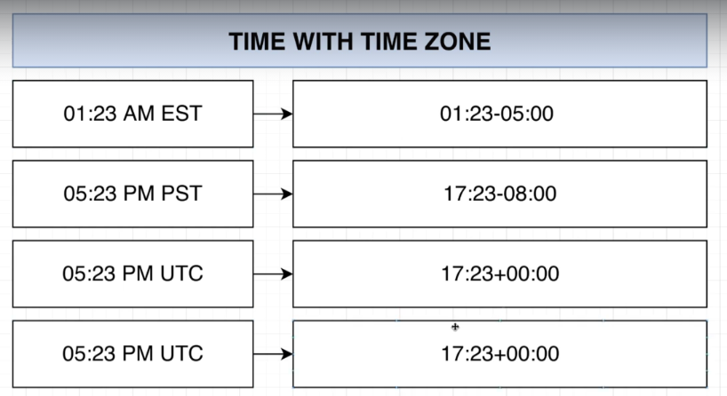

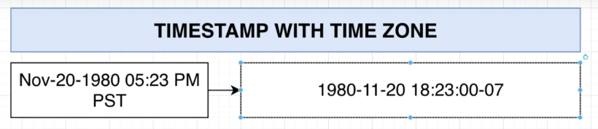

## 134. Really Awesome Intervals

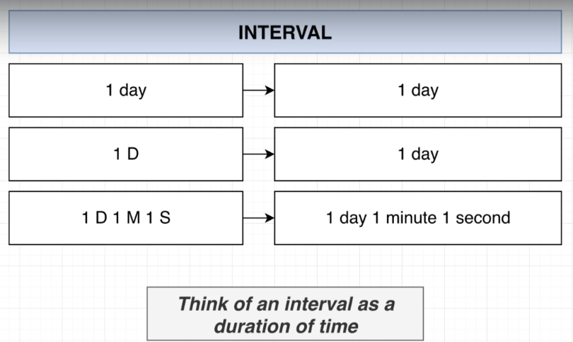

## 135. Thinking About Validation

## 136. Creating and Viewing Tables in PGAdmin

## 137. Applying a Null Constraint

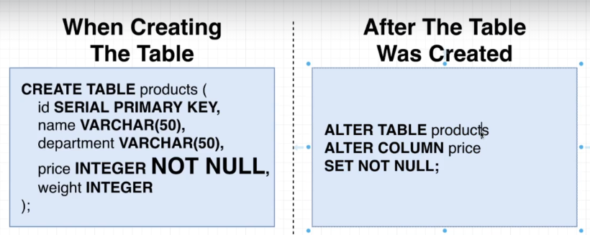

## 138. Solving a Gotcha with Null Constraints

## Quiz 11: Creating NULL Constraints

## 139. Default Column Values

## 140. Applying a Unique Constraint to One column

## 141. Multi-Column Uniqueness

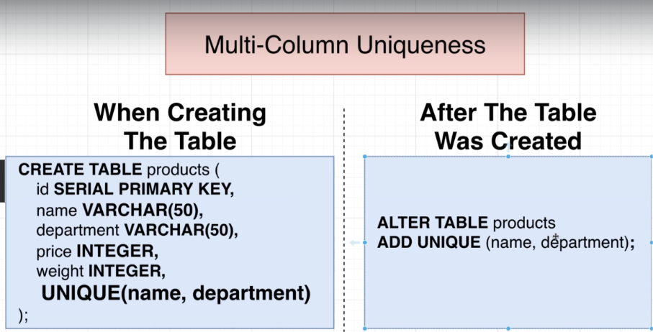

## Quiz 12: Is It Unique?

## 142. Adding a Validation Check

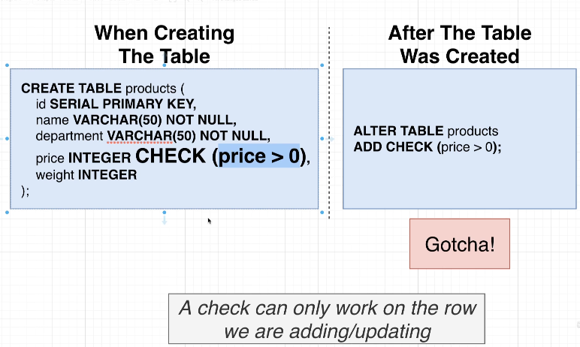

## 143. Checks Over Multiple Columns

## Quiz 13: Does It Pass a Check?

## 144. So Where Are We Applying Validation?

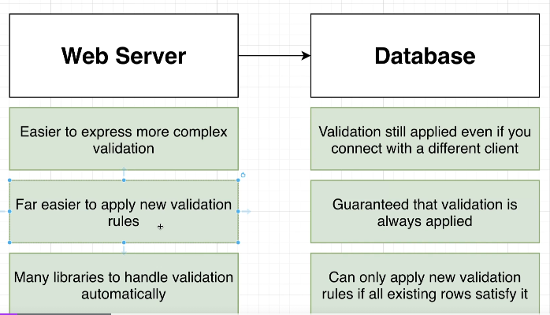

## 145. Approaching More Complicated Designs

## 146. Using a SQL Design Tool

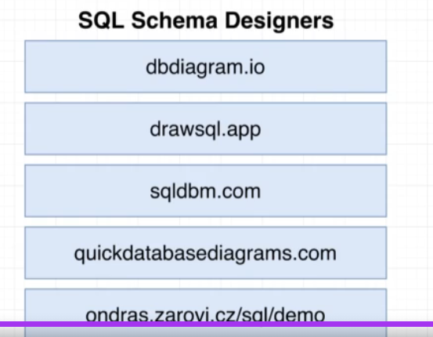

## 147. A Config-based Schema Designer

## 148. Here's the Plan

## 149. Rebuilding Some Schema

## 150. Requirements of a Like System

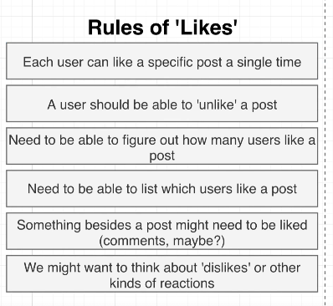

## 151. How Not to Design a Like System

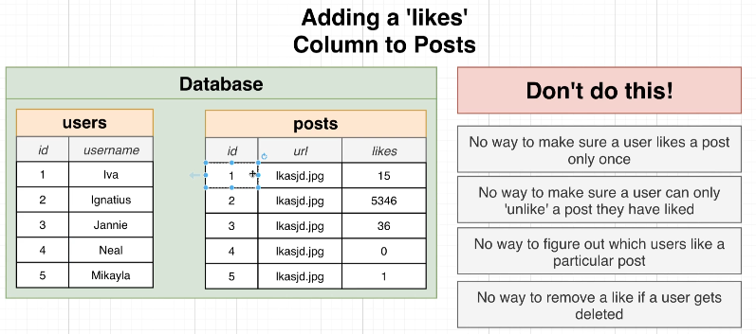

## 152. Designing a Like System

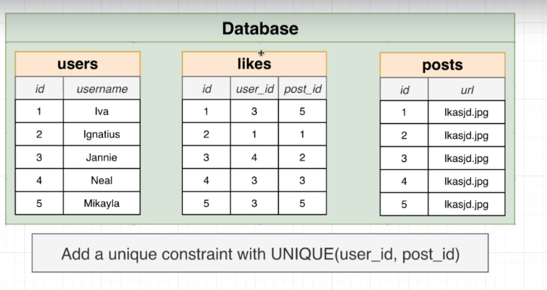

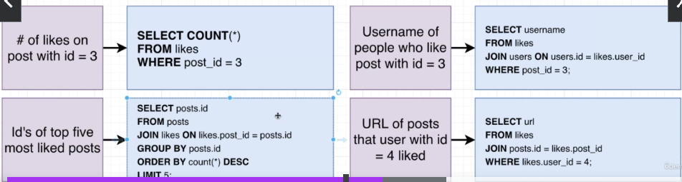

## Quiz 14: Building a Similar System

## 153. Making a Reaction System Instead

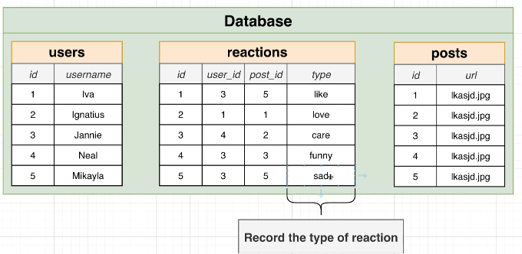

## 154. Polymorphic Associations

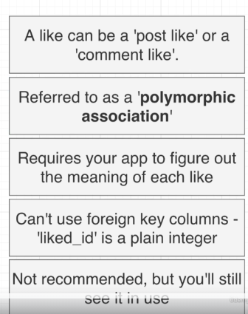

Like_type 🡪 post or comment

## 155. Polymorphic Association Alternative Implementation

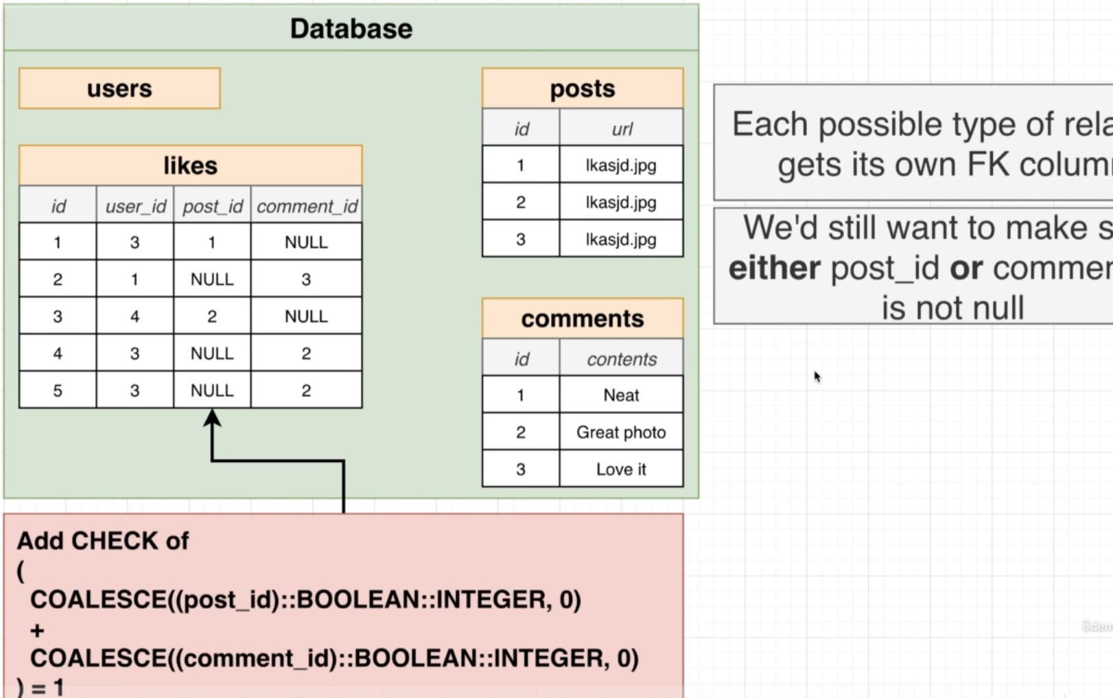

COALESCE gives first non null value

COALESCE(null,5) 🡪 5

## 156. The Simplest Alternative

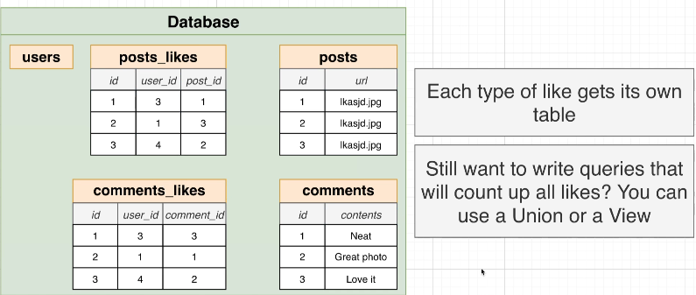

## Quiz 15: Polymorphic Associations

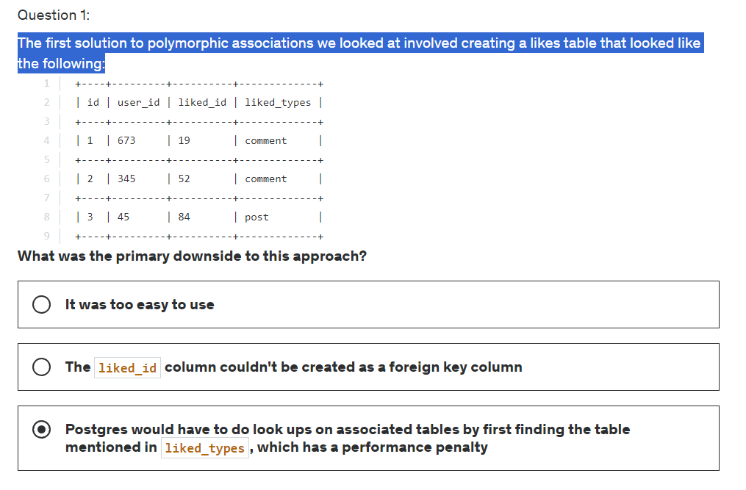

Option2 is correct

## 157. So Which Approach?

## 158. Additional Features Around Posts

## 159. Adding Captions and Locations

## 160. Photo Mentions vs Caption Mentions

## 161. Considerations on Photo Tags vs Caption Tags

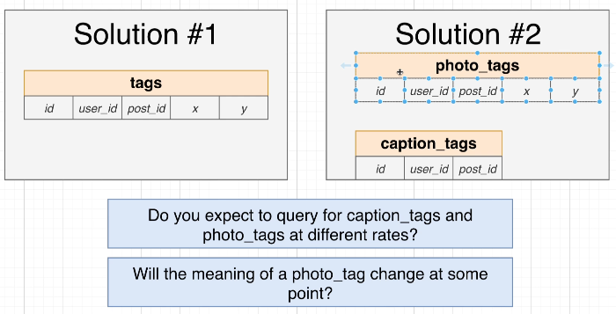

## 162. Update For Tags

## 163. Designing a Hashtag System

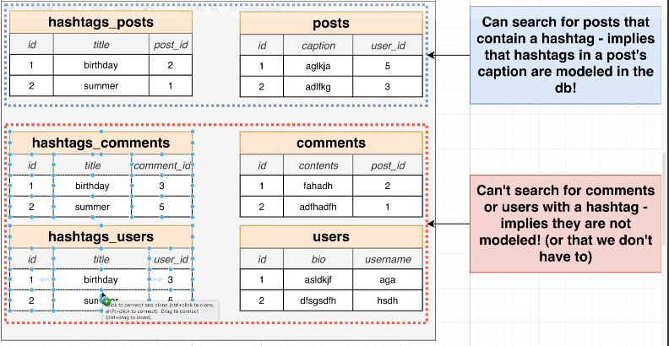

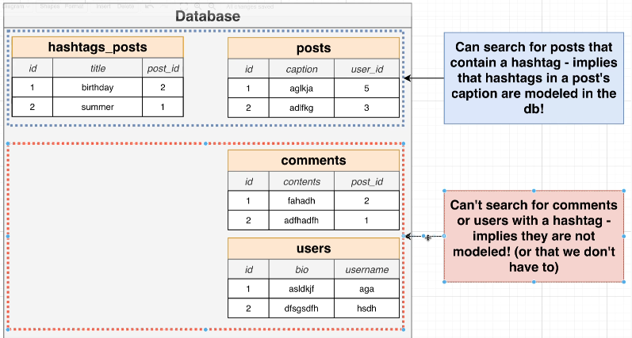

## 164. Tables for Hashtags

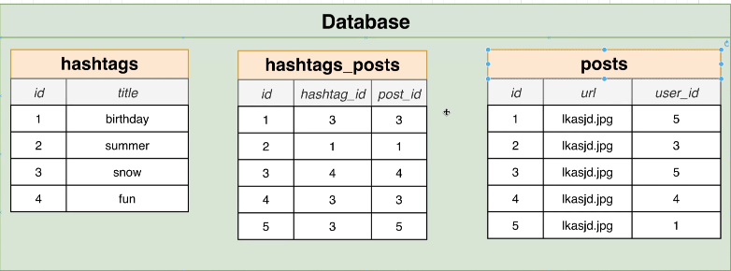

## 165. Including the Hashtag Table

## 166. A Few More User Columns

## 167. Why No Number of Followers or Posts?

## 168. Designing a Follower System

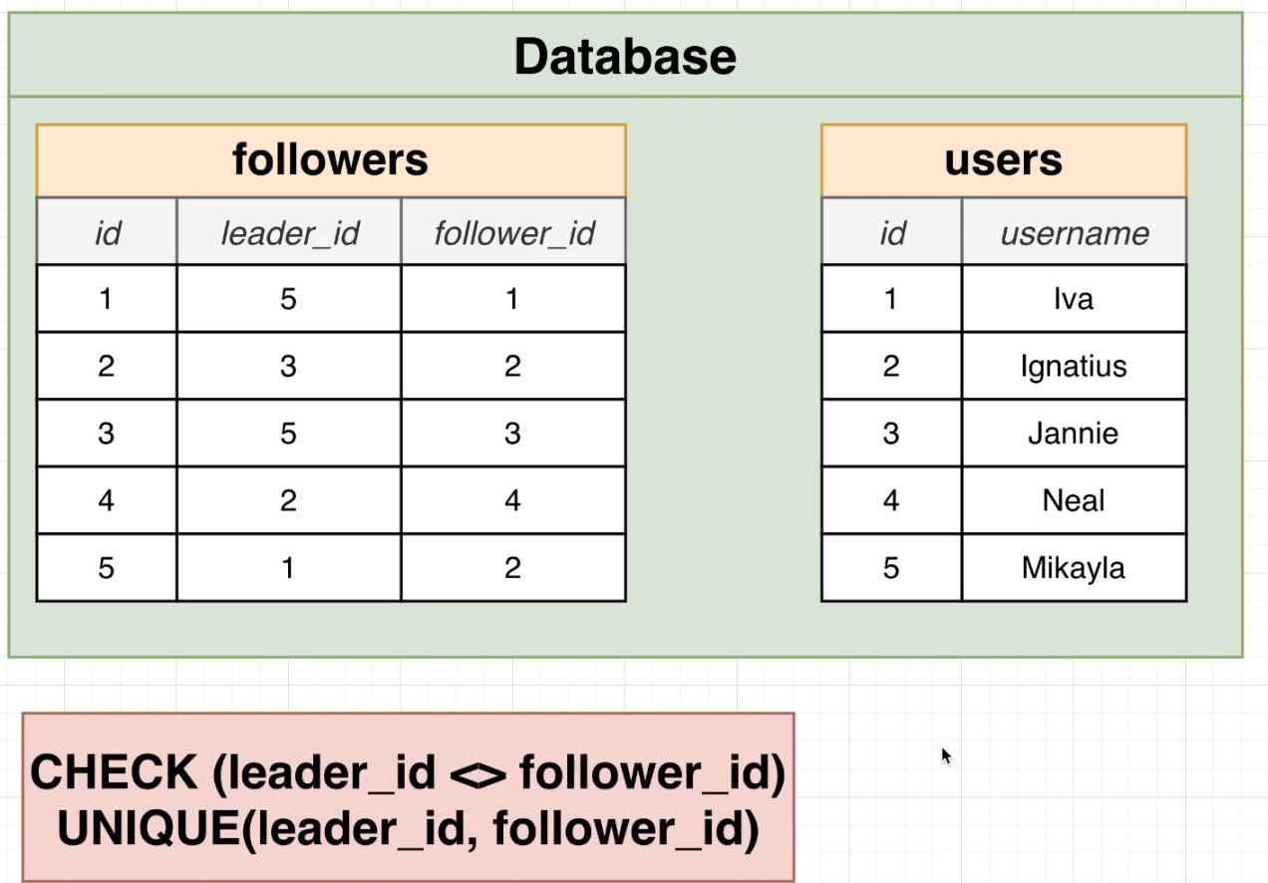

## 169. Back to Postgres

## 170. Creating Tables with Checks

## 171. Posts Creation

## 172. Comments Creation

## 173. Likes Creation

## 174. Photo Tags and Caption Tags

## 175. Creating Hashtags, Hashtag Posts, and Followers

## 176. Quick Note About Adding Some Data

## 177. Adding Some Data

## 178. Restoring from Scratch

## 179. Highest User ID's Exercise

## 180. Solution for User ID's

## 181. Posts by a Particular User

## 182. Solving for Posts by User

## 183. Likes Per User

## 184. Solution for Likes Per User

## 185. Thinking About Performance

## 186. Where Does Postgres Store Data?

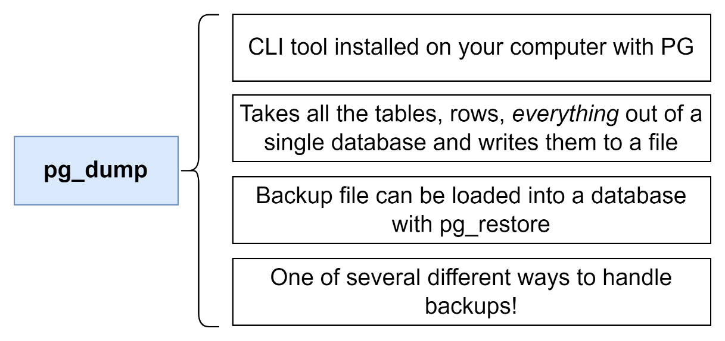

Show data_directory;

Base 🡪

Select oid, datname

From pg_database;

Select * from pg_class;

## 187. Heaps, Blocks, and Tuples

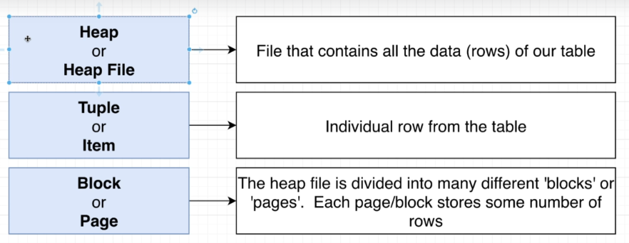

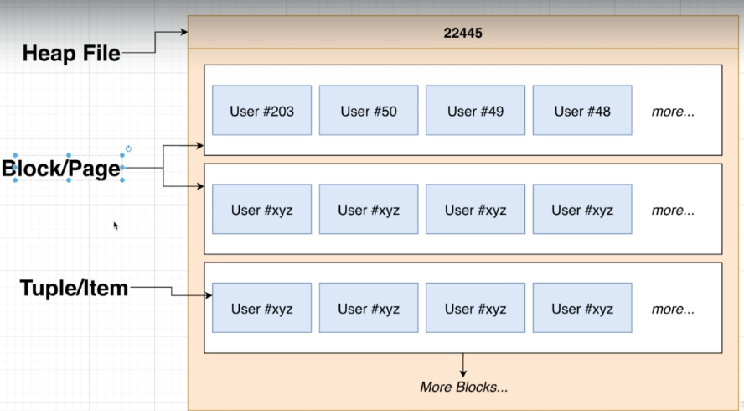

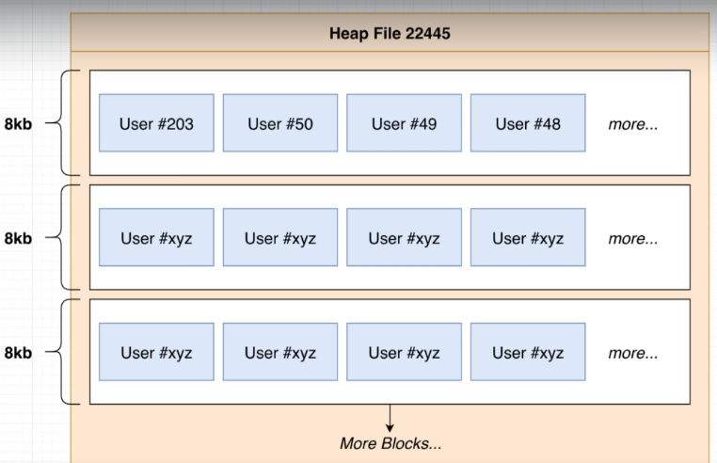

## Quiz 16: Terminology Check

## 188. Block Data Layout

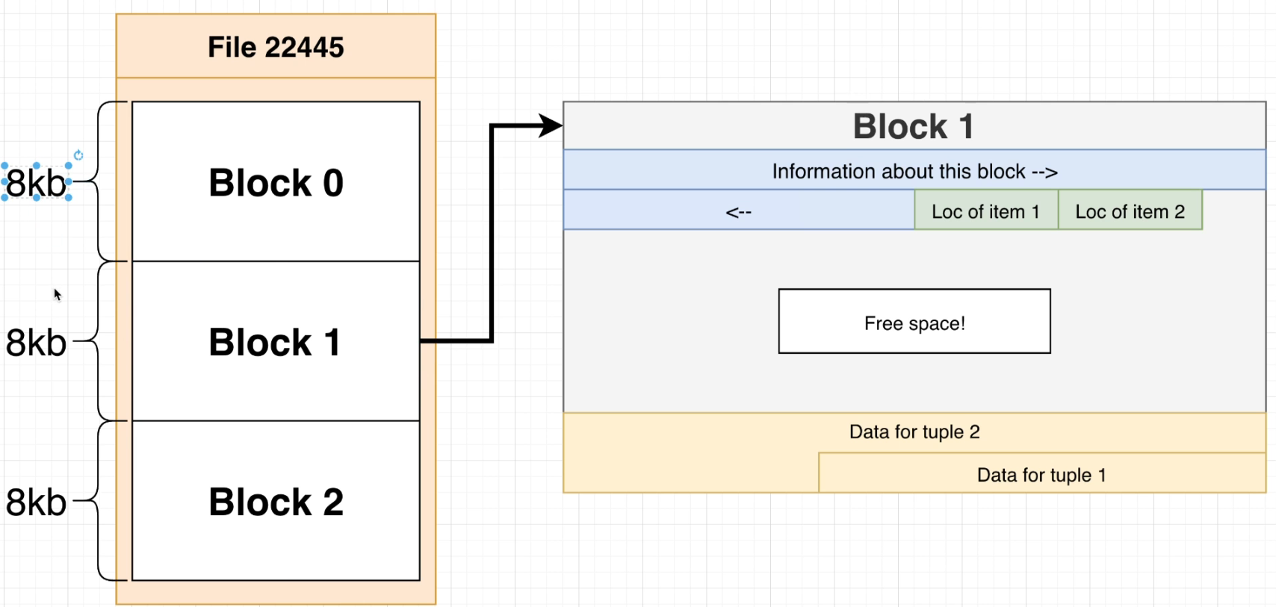

## 189. Heap File Layout

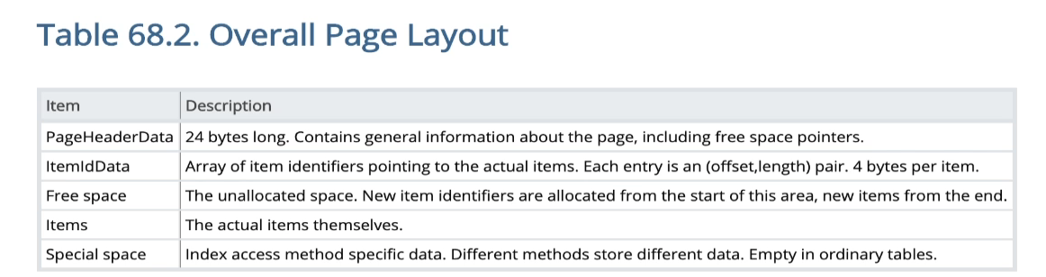

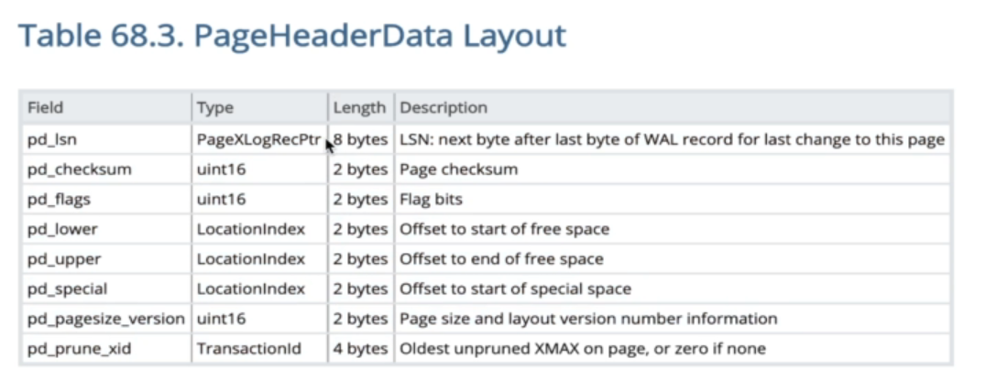

## 190. Full Table Scans

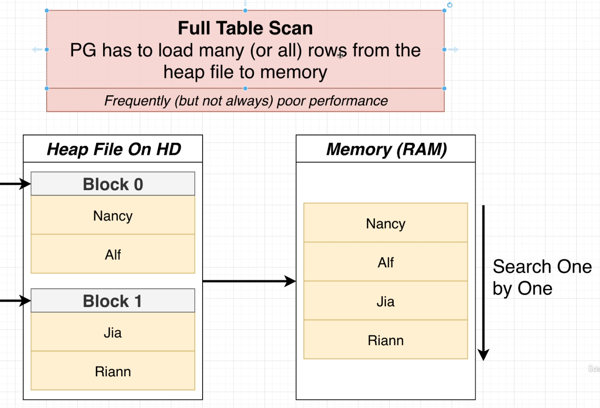

## 191. What's an Index

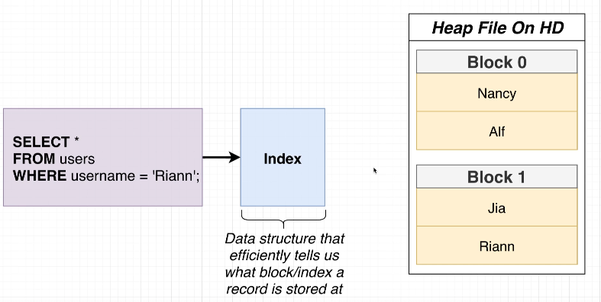

## 192. How an Index Works

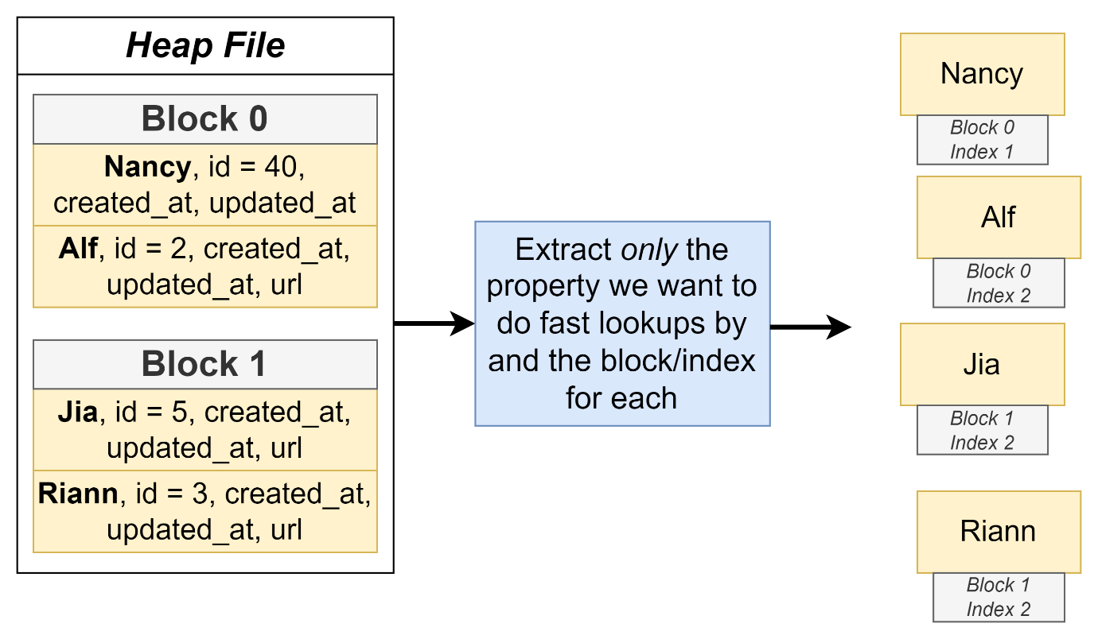

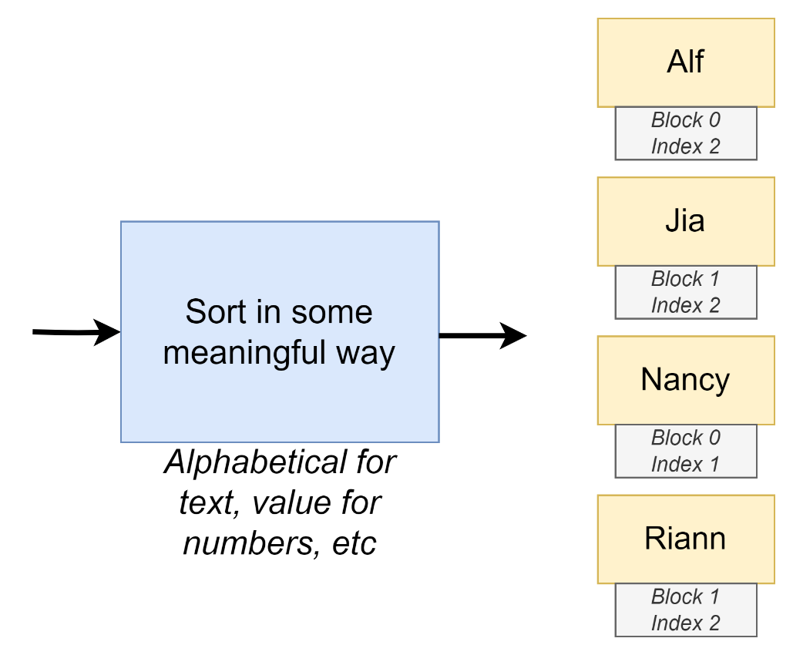

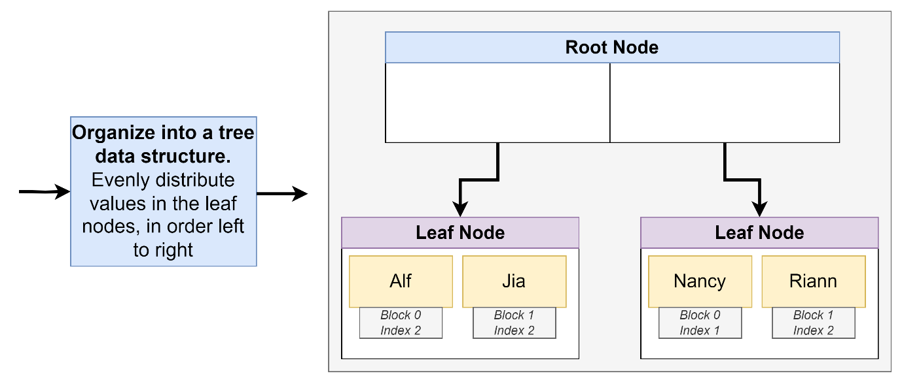

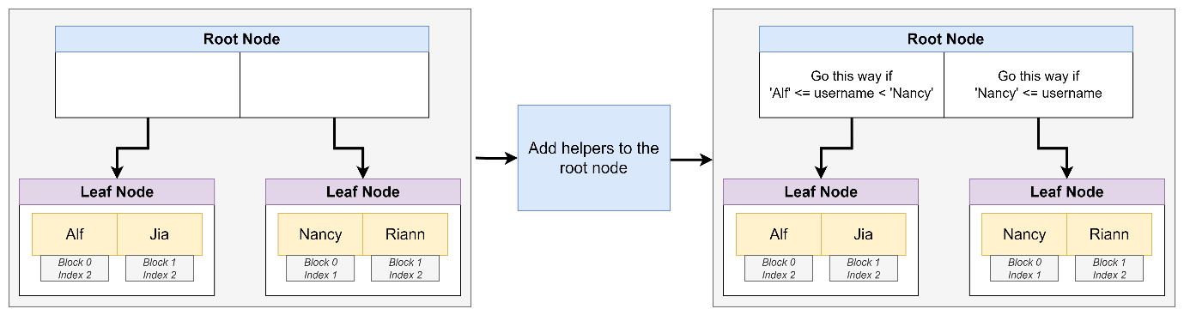

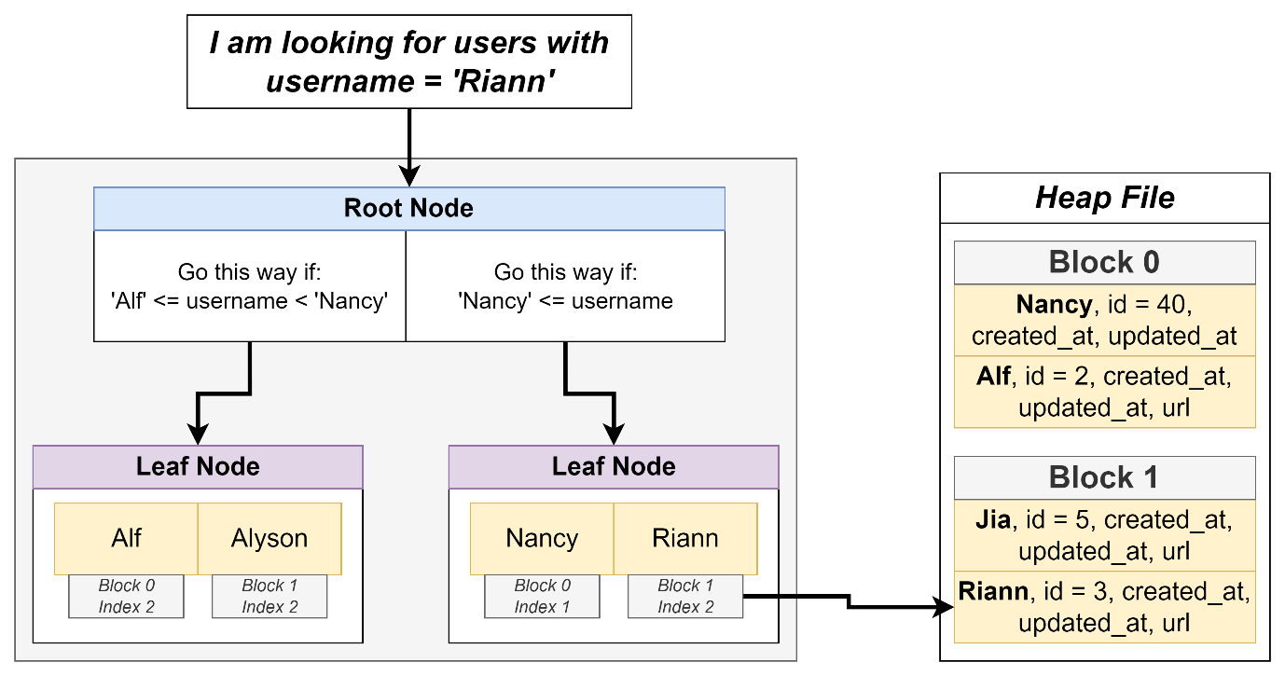

## 193. Creating an Index

CREATE INDEX users_username_idx ON users(username);

## 194. Benchmarking Queries

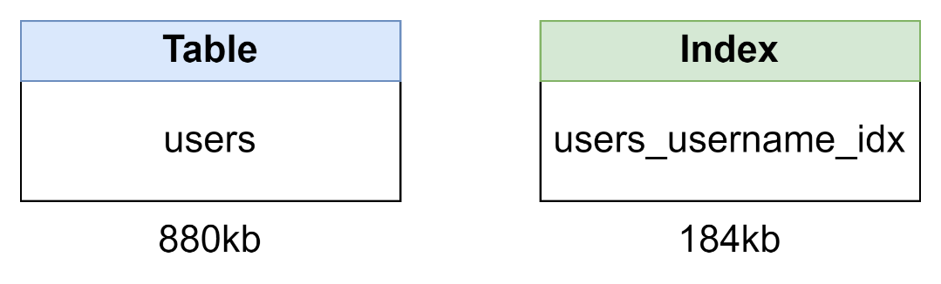

## 195. Downsides of Indexes

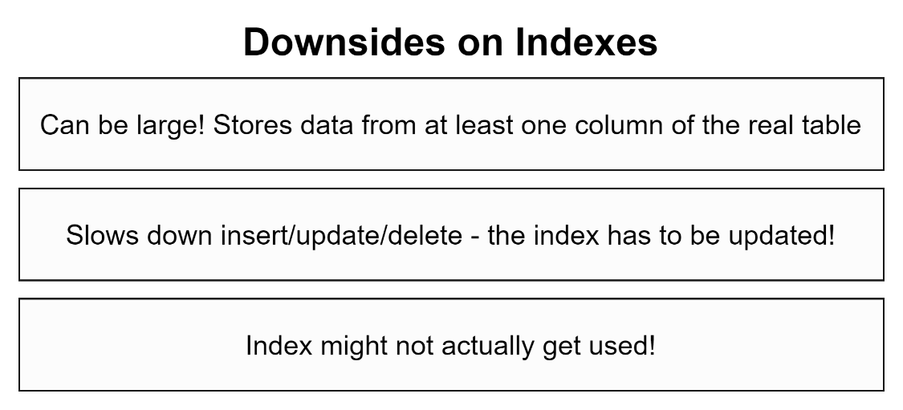

## 196. Index Types

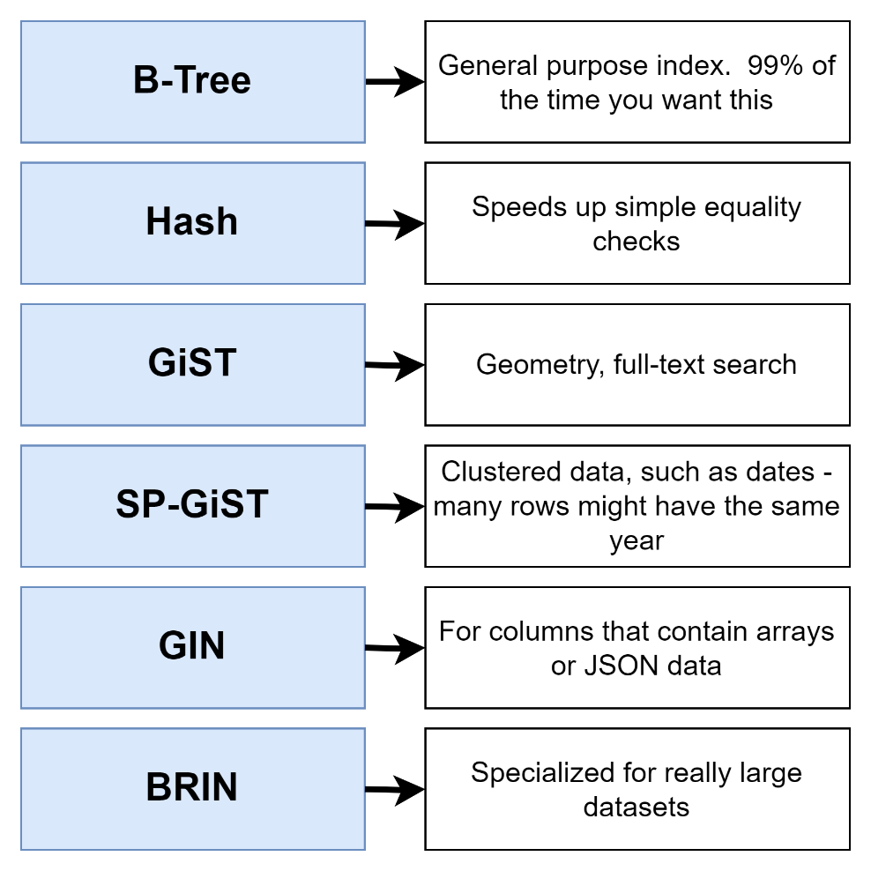

## 197. Automatically Generated Indexes

Select 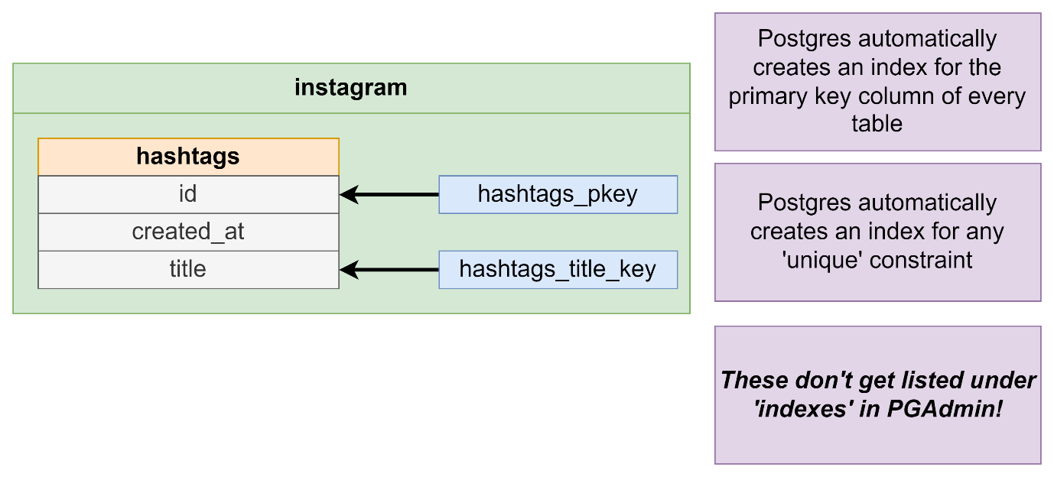

Select pg_size_pretty(pg_relation_size(‘users_username_idx’))

Select relname, relkind

From og_class

Where relkind = ‘i’;

## Quiz 17: Using Automatically Created Indexes

## 198. Behind the Scenes of Indexes

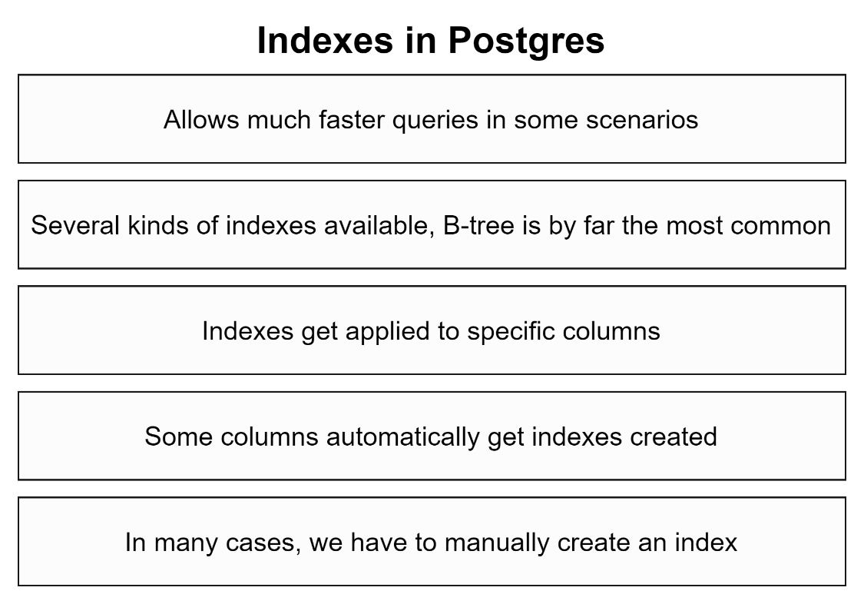

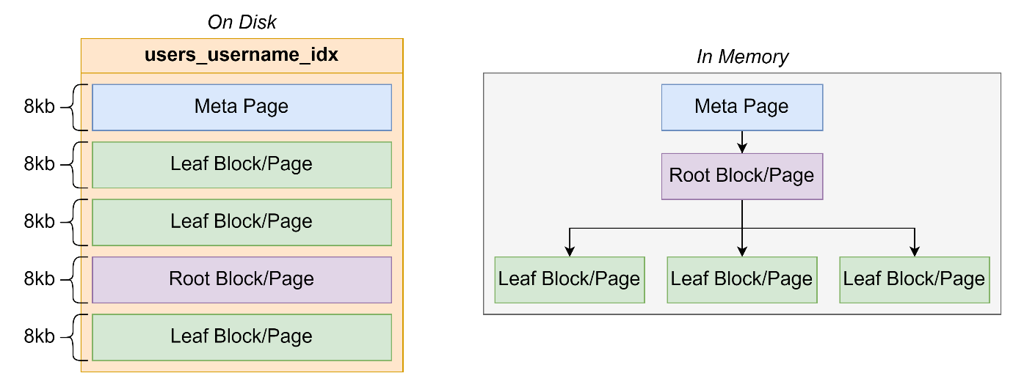

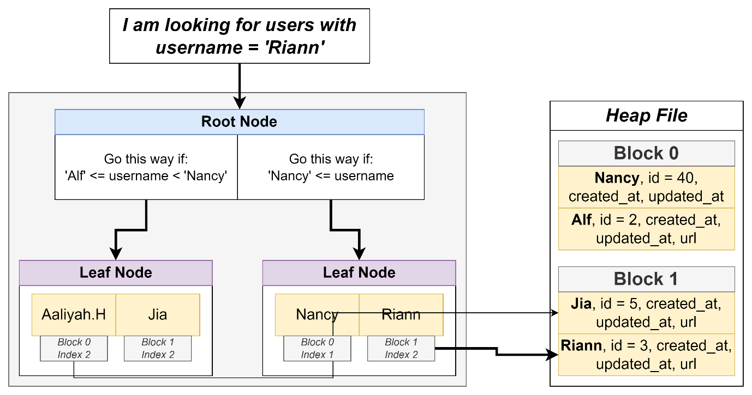

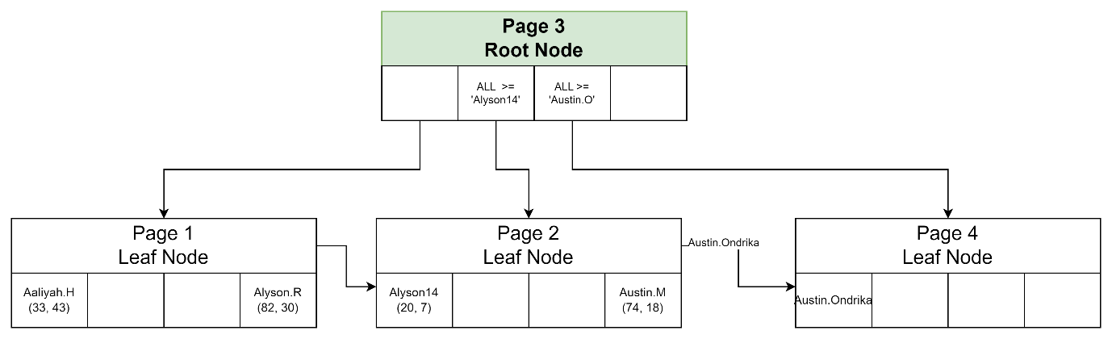

## 

## 199. The Query Processing Pipeline

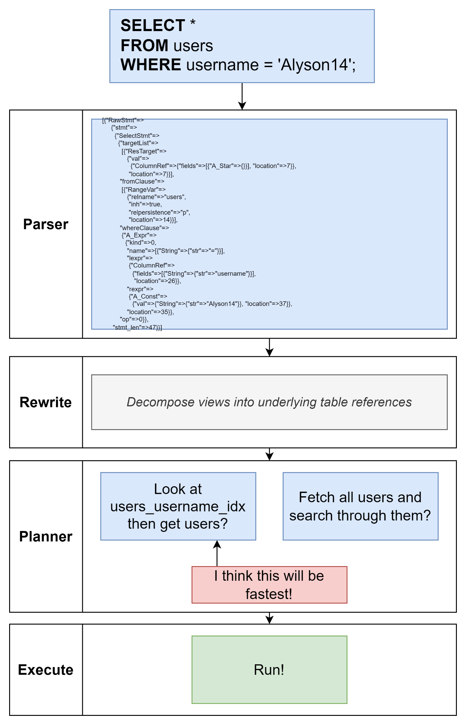

## 200. Explain and Explain Analyze

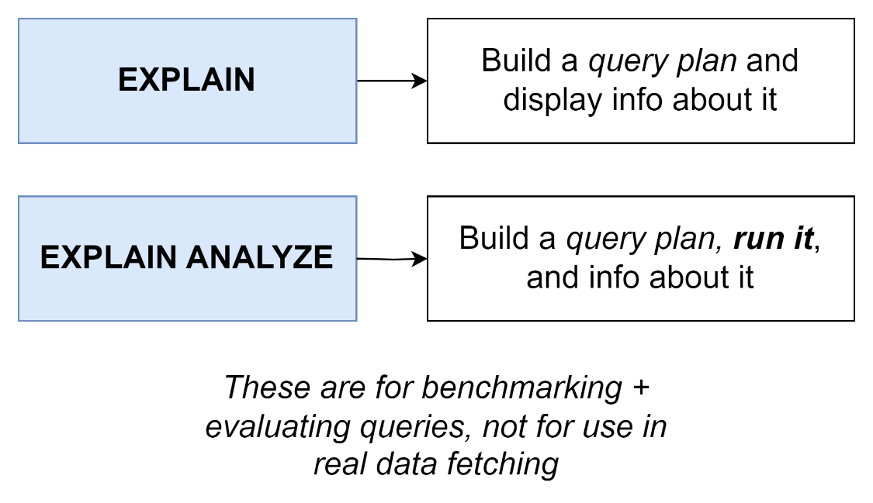

## Quiz 18: Explain Vs Explain Analyze

## 201. Solving an Explain Mystery

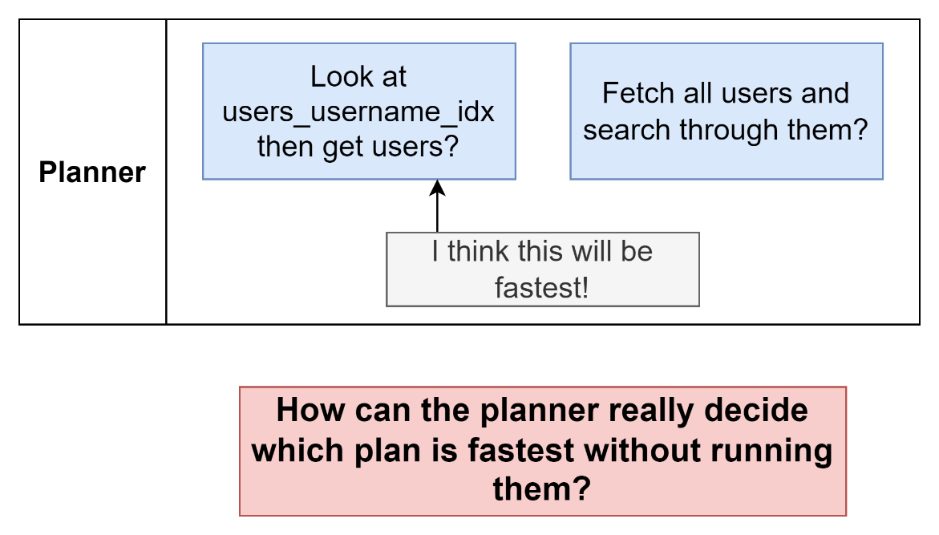

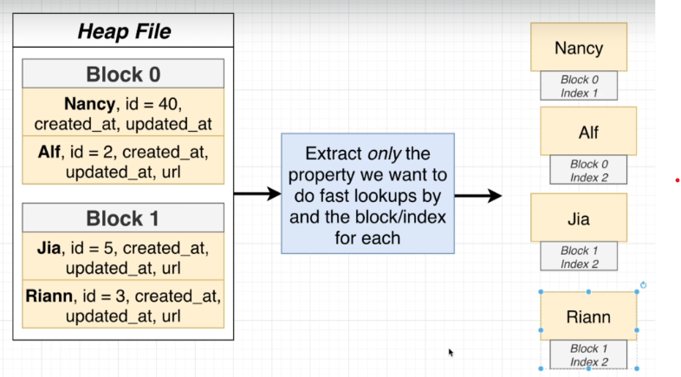

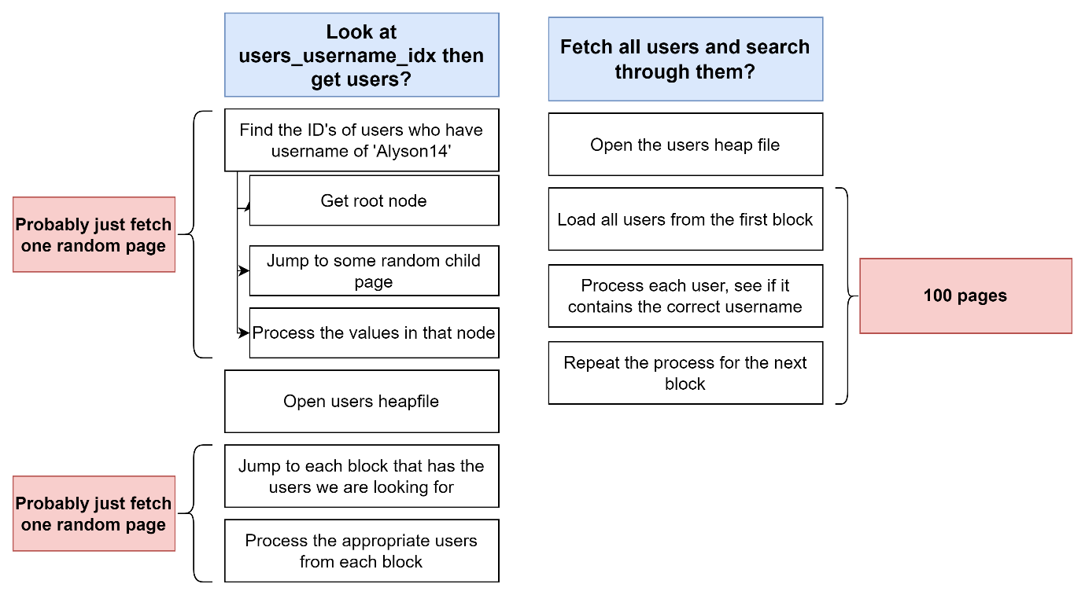

## 202. Developing an Intuitive Understanding of Cost

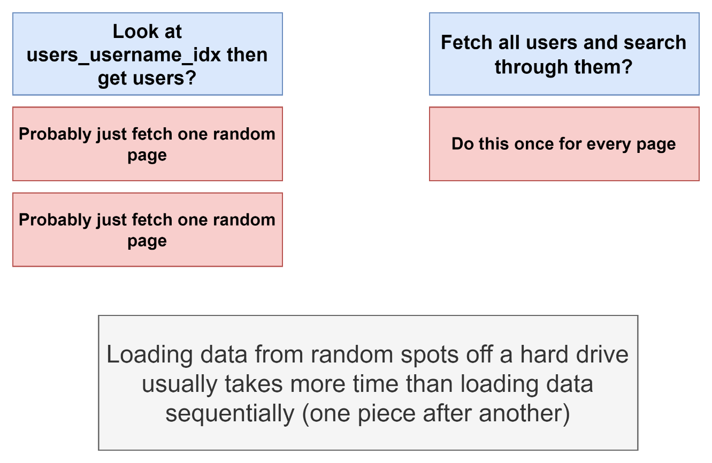

## 203. Calculating Cost by Hand

## 204. A Touch More on Costs

## Quiz 19: Calculating Costs

## 205. up vs Total Costs

## 206. Costs Flow Up

## 207. Use My Index!

## 208. Common Table Expressions

## 209. A Quick Solution

## 210. So What's a CTE?

## 211. Recursive CTE's

## 212. Recursive CTE's Step by Step

## 213. Why Use Recursive CTE's?

## 214. Writing the Query

## 215. Walking Through Recursion

## 216. Most Popular Users

## 217. A Possible Solution for Merging Tables

## 218. Creating a View

## 219. When to Use a View?

## 220. Deleting and Changing Views

## 221. Materialized Views

## 222. Grouping by Week

## 223. Reminder on Left Joins

## 224. Writing a Slow Query

## 225. Creating and Refreshing Materialized Views

## Quiz 20: Views vs Materialized Views

## 226. What are Transactions Used For?

## 227. Some Sample Data

## 228. Opening and Closing Transactions

## 229. Transaction Cleanup on Crash

## 230. Closing Aborted Transactions

## 231. A Story on Migrations

## 232. Migration Files

## 233. Issues Solved by Migrations

## 234. A Few Notes on Migrations Libraries

## 235. A Note About Node Installation

## 236. Project Creation

## 237. Generating and Writing Migrations

## 238. Applying and Reverting Migrations

## 239. Generating and Applying a Second Migration

## 240. Schema vs Data Migrations

## 241. Dangers Around Data Migrations

## 242. Properly Running Data and Schema Migrations

## 243. Creating a Posts Table

## 244. A Small Web Server

## 245. Web Server Setup Instructions

## 246. Adding the Loc Column

## 247. Writing Values to Both Columns

## 248. Transaction Locks

## 249. Updating Values

## 250. Migrations Setup Instructions

## 251. Updating the App Server

## 252. Dropping the Last Columns

## 253. Section Goal

## 254. Initial Setup

## 255. One Fast Migration

## 256. Building the Users Router

## 257. Understanding Connection Pools

## 258. Validating Connection Credentials

## 259. Query and Close

## 260. The Repository Pattern

## 261. Creating a Repository

## 262. Accessing the API

## 263. Casing Issues

## 264. Fixing Casing

## 265. Finding Particular Users

## 266. SQL Injection Exploits

## 267. Handling SQL Injection with Prepared Statements

## 268. Preventing SQL Injection

## 269. Reminder on Post Requests

## 270. Inserting Users

## 271. Handling Updates

## 272. And, Finally, Delete

## 273. A Note on Testing

## 274. Assertions Around User Count

## 275. Connecting to a DB For Tests

## 276. Disconnecting After Tests

## 277. Multi-DB Setup

## 278. Assumptions Around Content

## 279. Issues with Parallel Tests

## 280. Isolation with Schemas

## 281. Creating and Accessing Schemas

## 282. Controlling Schema Access with Search Paths

## 283. Routing Schema Access

## 284. Strategy for Isolation

## 285. Programmatic Schema Creation

## 286. Escaping Identifiers

## 287. Test Helpers

## 288. Cleaning up Schemas and Roles

## 289. Finally... Parallel Tests! (Final Lecture)

## 290. Bonus!